SNARM500 4dof robot arm Arduino kit

<https://smallhammer.cc/docs/snam500/>

SNAM500 4DOF robot arm install guide

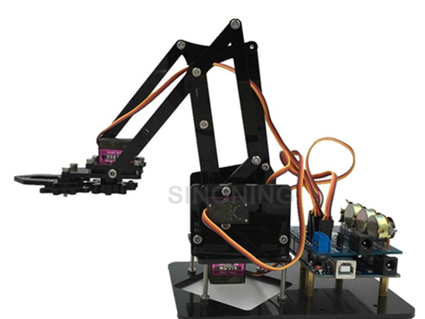

Articles

* [About](https://smallhammer.cc/docs/snam500/about/)
* [Package list](https://smallhammer.cc/docs/snam500/package-list/)
* [1. expansion board soldering guide](https://smallhammer.cc/docs/snam500/expansion-board-soldering-guide/)
  + [1.2 soldering](https://smallhammer.cc/docs/snam500/expansion-board-soldering-guide/soldering/)
  + [1.3 connection expansion board to arduino](https://smallhammer.cc/docs/snam500/expansion-board-soldering-guide/connection/)
  + [1.4 servos on arm](https://smallhammer.cc/docs/snam500/expansion-board-soldering-guide/servos-on-arm/)
  + [1.1 example show](https://smallhammer.cc/docs/snam500/expansion-board-soldering-guide/1-1-example-show/)
* [2. Test servo](https://smallhammer.cc/docs/snam500/test-servo/)
* [3. install servo on acrylic parts](https://smallhammer.cc/docs/snam500/install-servo-on-acrylic-parts/)
* [arduino code](https://smallhammer.cc/docs/snam500/arduino-code/)
* [Note](https://smallhammer.cc/docs/snam500/note/)
* [update log](https://smallhammer.cc/docs/snam500/update-log/)

# About

SNARM Control is also very simple, with four knobs to control the movement of each potentiometer. After connecting to the computer with USB, you can send commands through the serial port to control the movement of the servo. At the same time compatible with other computer control software, also supports their own write procedures, the implementation of fixed repetitive action.

# Package list

1, black acrylic cutting 1 set

2,MG90S   servo 4 pcs

3, Arduino UNO 1 pcs

4, Arduino extension board  1 pcs (need weld)

5. screw some

6. 5V 2A power adapter US plug

7. screw driver

# 1. expansion board soldering guide

### Articles

* [1.2 soldering](https://smallhammer.cc/docs/snam500/expansion-board-soldering-guide/soldering/)
* [1.3 connection expansion board to arduino](https://smallhammer.cc/docs/snam500/expansion-board-soldering-guide/connection/)
* [1.4 servos on arm](https://smallhammer.cc/docs/snam500/expansion-board-soldering-guide/servos-on-arm/)
* [1.1 example show](https://smallhammer.cc/docs/snam500/expansion-board-soldering-guide/1-1-example-show/)

# 1.2 soldering

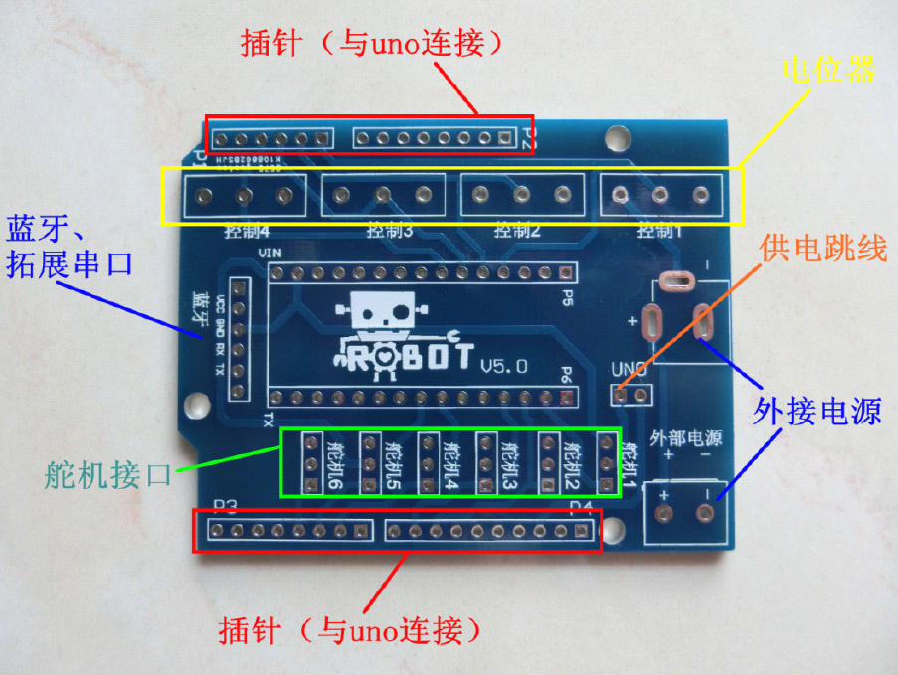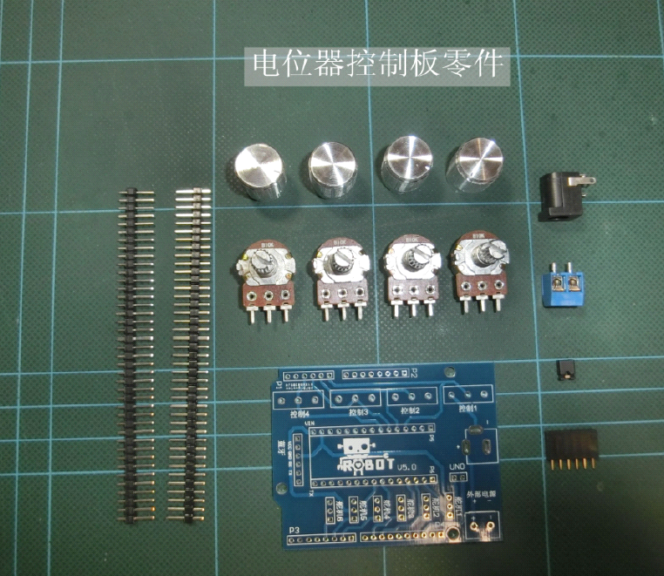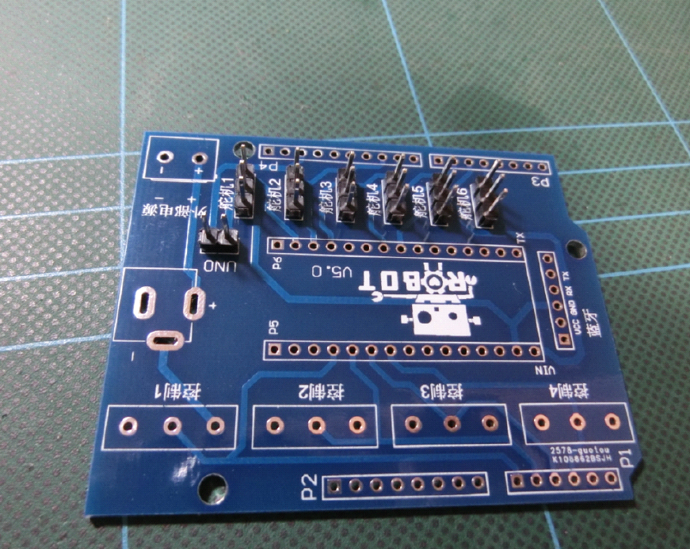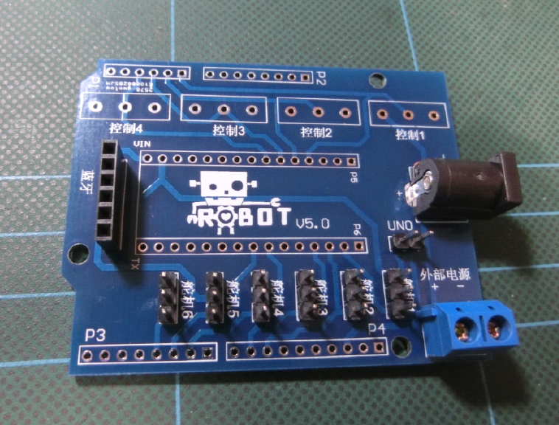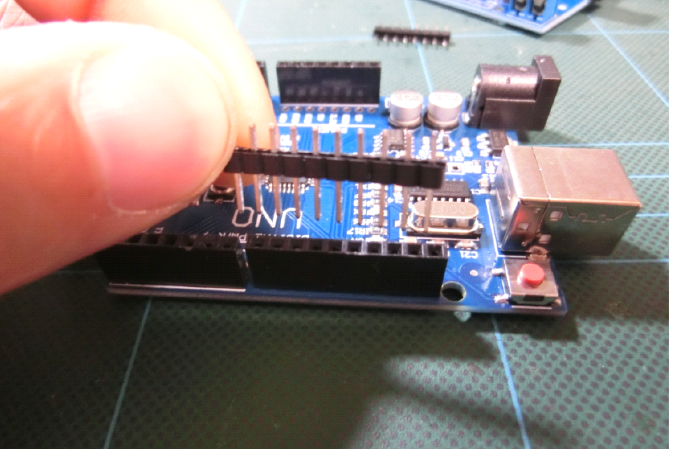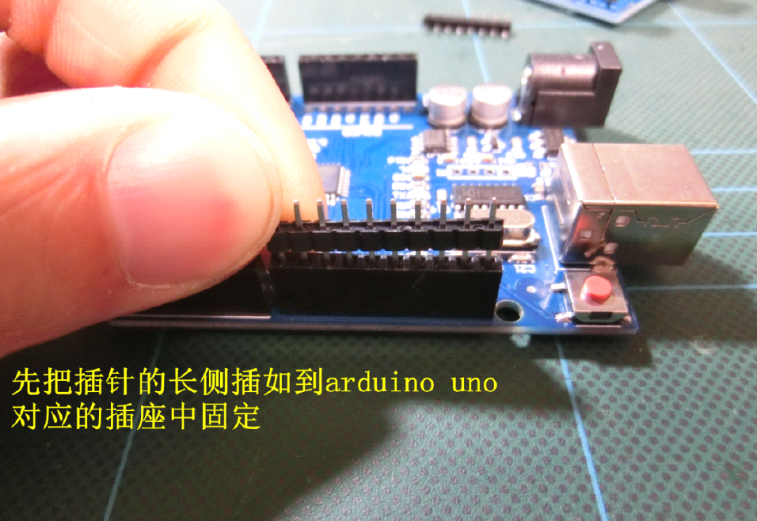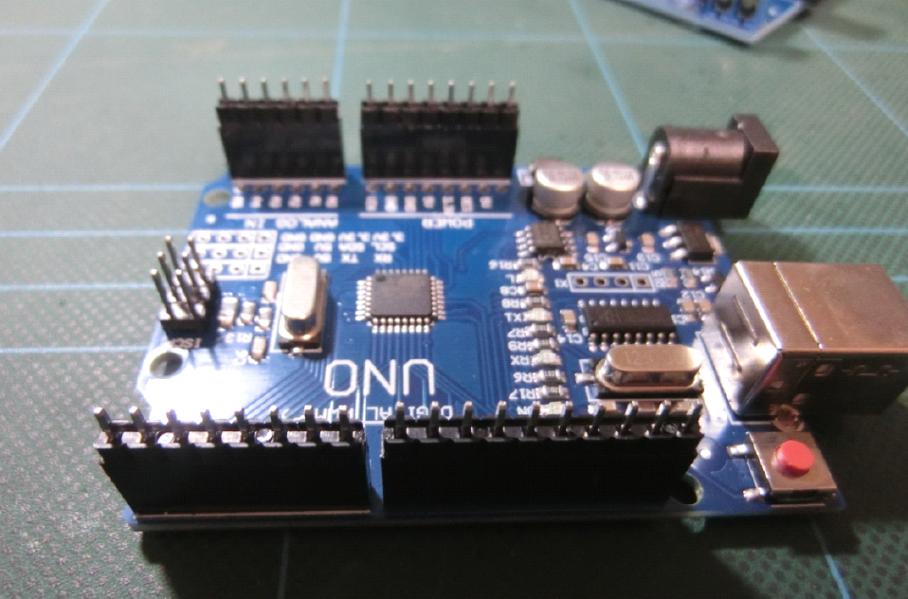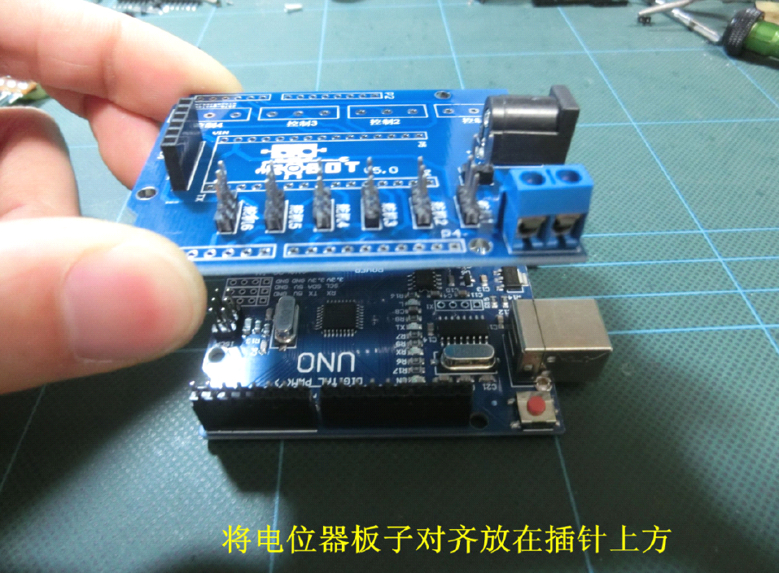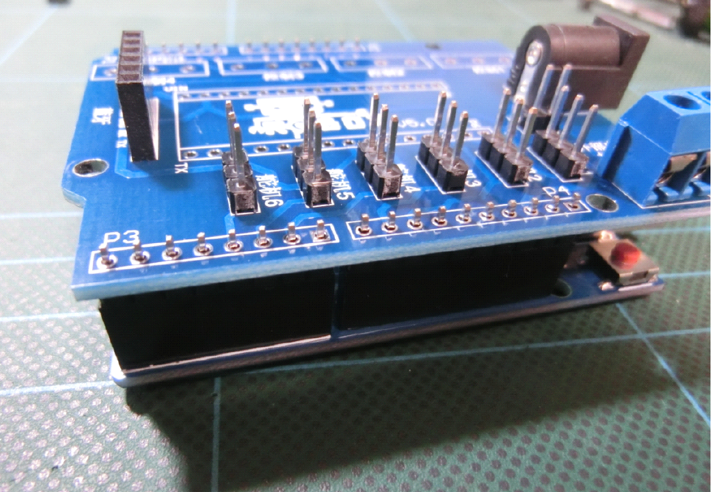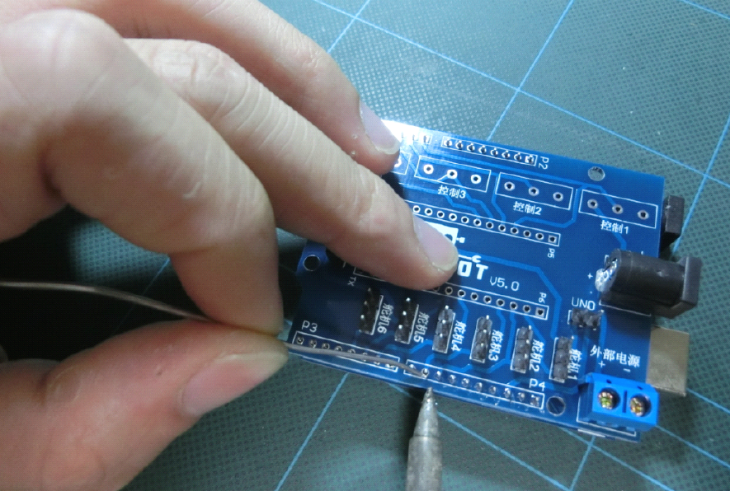

# 1.3 connection expansion board to arduino

**Hardware connection principle:**

expansion board ———- arduino port  
Control 1 ——— A0  
Control 2 ——— A1  
Control 3 ——— A2  
Control 4 ——— A3

**Servo:-arduino**

Servo 1 ——— D11  
Servo 2 ——— D10  
Servo 3 ——— D9  
Servo 4 ——— D6

# 1.4 servos on arm

**Place all four servos on the corresponding connector:**  
Claw –  —-Servo 1  
big Arm —– —Servo 2  
Small arm —– Servo 3  
Base —– Servo 4

# 1.1 example show

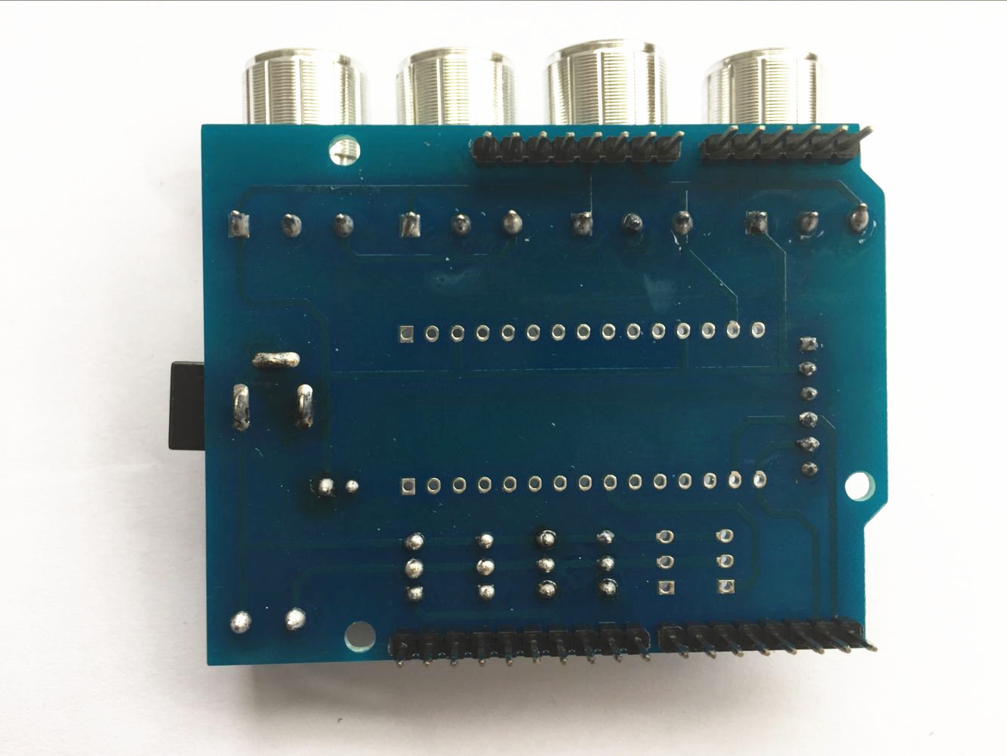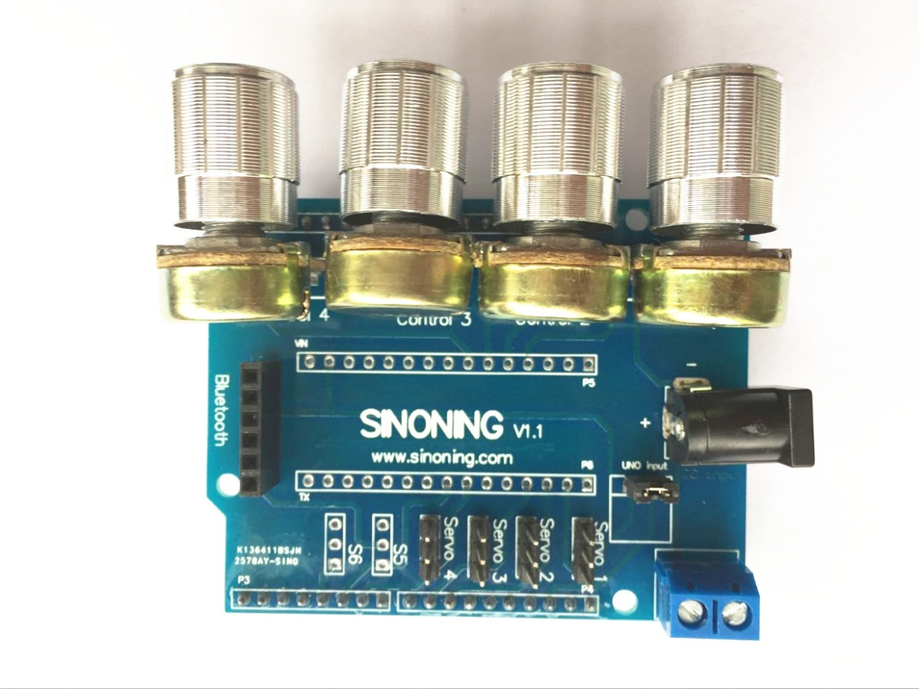

# 2. Test servo

before install servo on arm, test them

Connect the four servos to the corresponding circuit board, power up , make sure that each servo can be rotated, and then rotate the steering gear to the middle position.

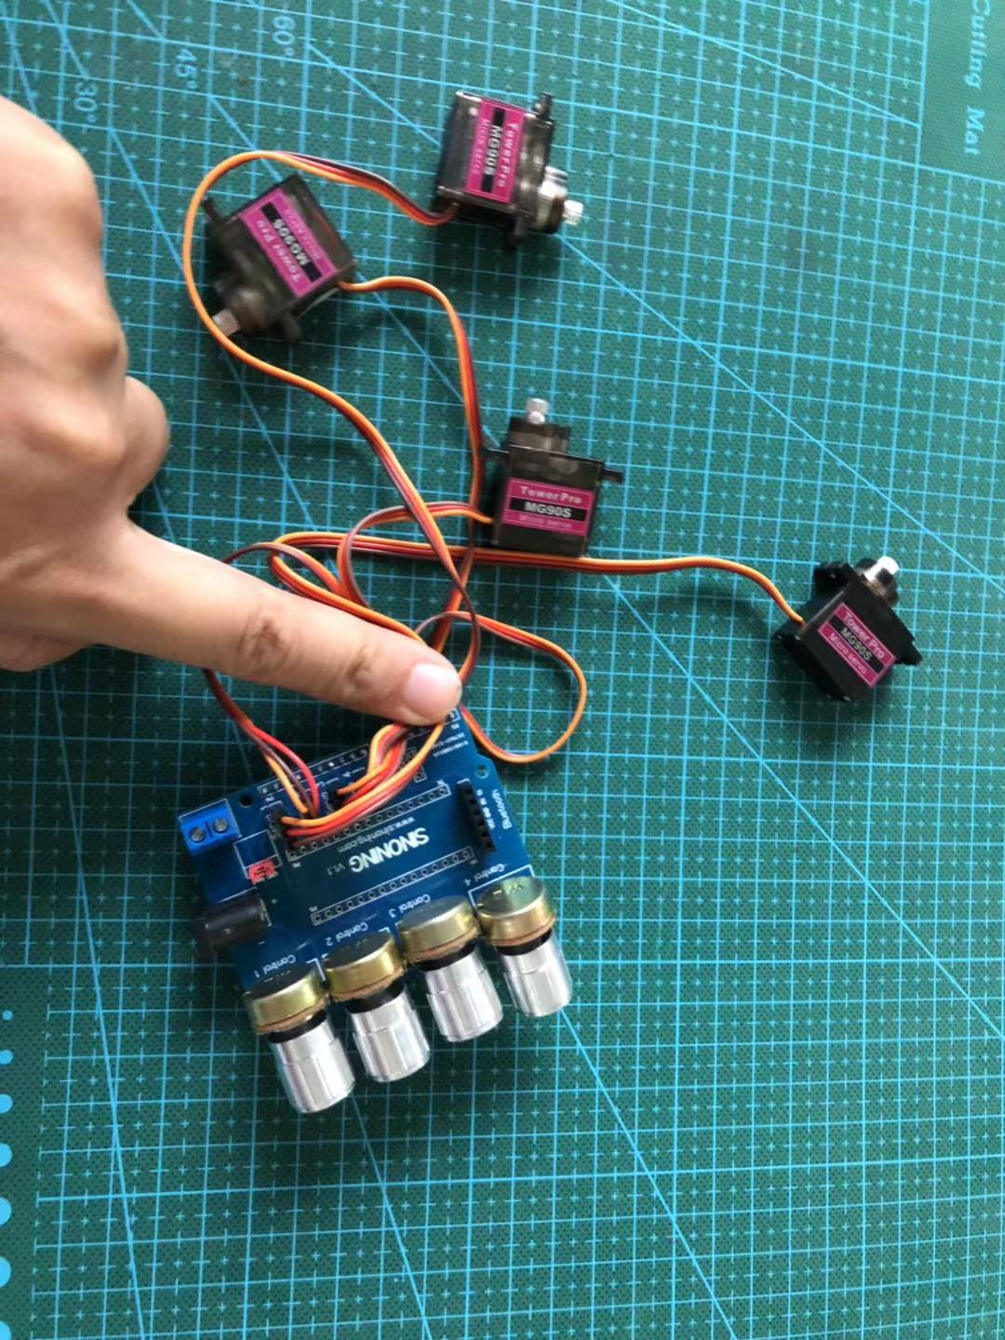

# 3. install servo on acrylic parts

# 4dof acrylic robot arm install guide

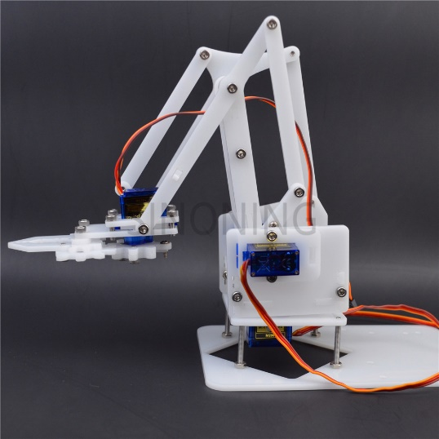

### Articles

* + [overview](https://smallhammer.cc/docs/4dof/over-view/)
  + [1. install video reference](https://smallhammer.cc/docs/4dof/install-video-reference/)
  + [2. install the base plate](https://smallhammer.cc/docs/4dof/install-the-base-plate/)
  + [3.install pivot servo](https://smallhammer.cc/docs/4dof/3-install-pivot-servo/)
  + [4. install servo on base plate](https://smallhammer.cc/docs/4dof/4-install-servo-on-base-plate/)
  + [5.install the bottom acrylic plate to pivot servo](https://smallhammer.cc/docs/4dof/5-install-the-bottom-acrylic-plate-to-pivot-servo/)
  + [6. install left arm servo](https://smallhammer.cc/docs/4dof/6-install-left-arm-servo/)
  + [7. install right Arm Servo on right plate](https://smallhammer.cc/docs/4dof/7-install-right-arm-servo-on-right-plate/)
  + [8. install center base plate join](https://smallhammer.cc/docs/4dof/8-install-center-base-plate-join/)
  + [9. connect the hull](https://smallhammer.cc/docs/4dof/9-connect-the-hull/)
  + [10, install main arm](https://smallhammer.cc/docs/4dof/10-install-main-arm/)
  + [11, install small arm](https://smallhammer.cc/docs/4dof/11-install-small-arm/)
  + [12.install grap](https://smallhammer.cc/docs/4dof/12-install-grap/)
  + [13, connect the claw](https://smallhammer.cc/docs/4dof/13-connect-the-claw/)
  + [update log](https://smallhammer.cc/docs/4dof/update-log/)

# overview

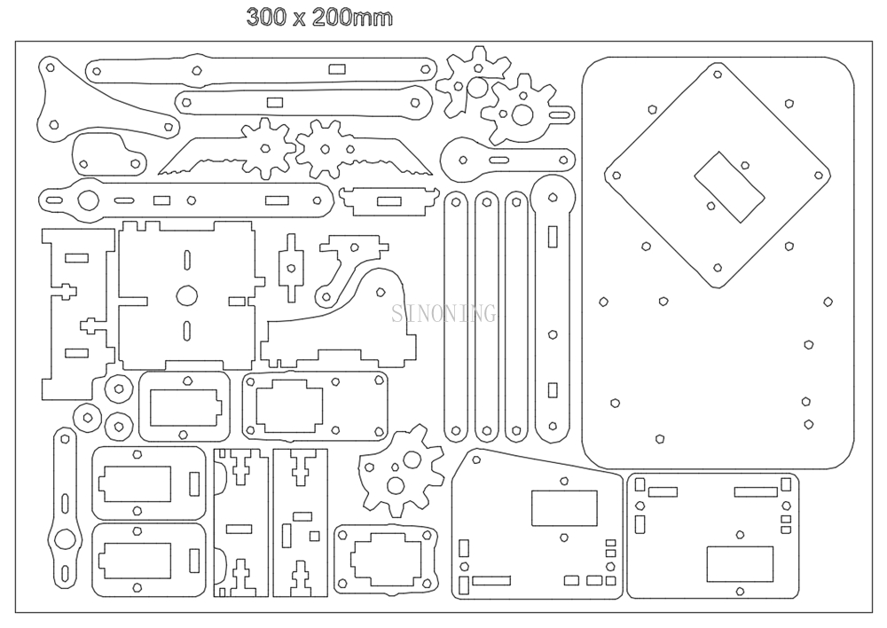

Note: the design may have some change

it made of acrylic

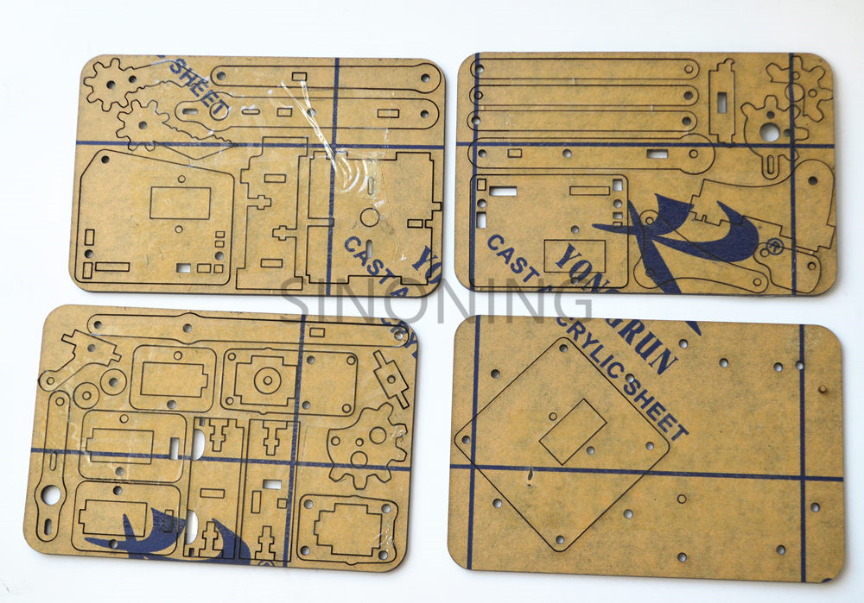

take off the protective film

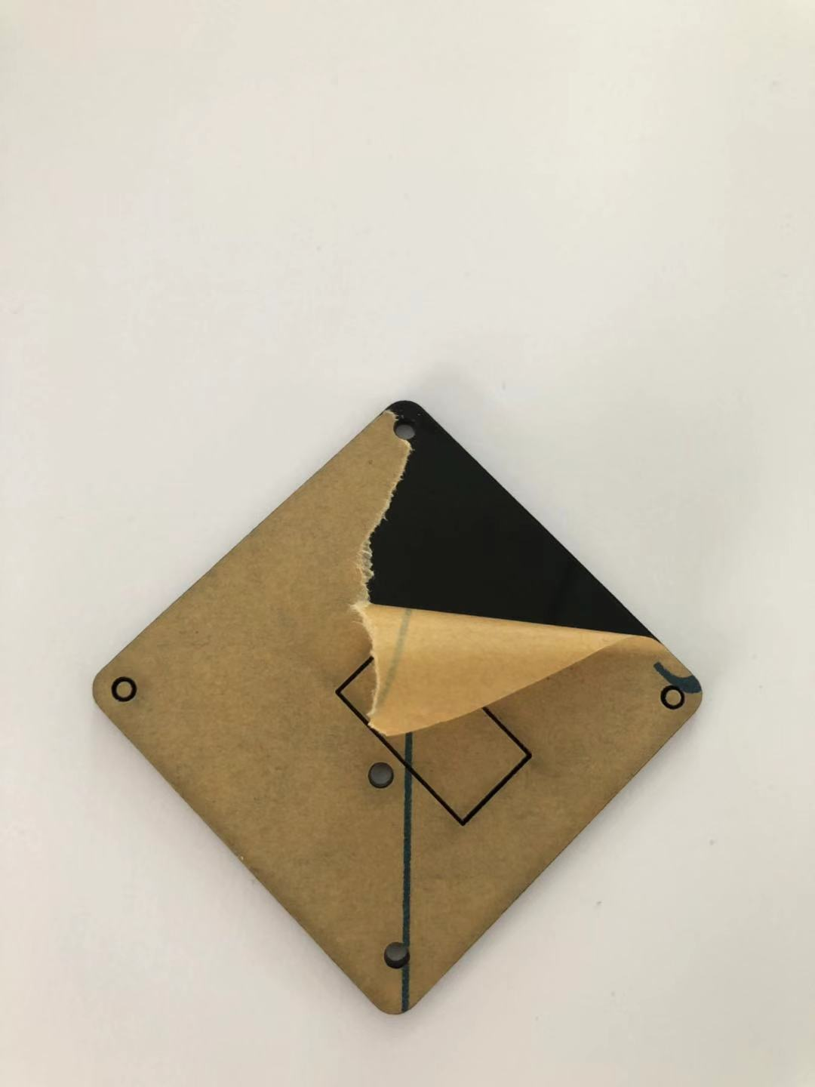

# 1. install video reference

Note: this video is a full smarm kit, it may differ from your kit, please just as a reference

thanks our customer from Russia has taken this video,

https://www.youtube.com/channel/UCWnYJoytogNmXg4BHZV8XLg

# 2. install the base plate

4pcs M3*30

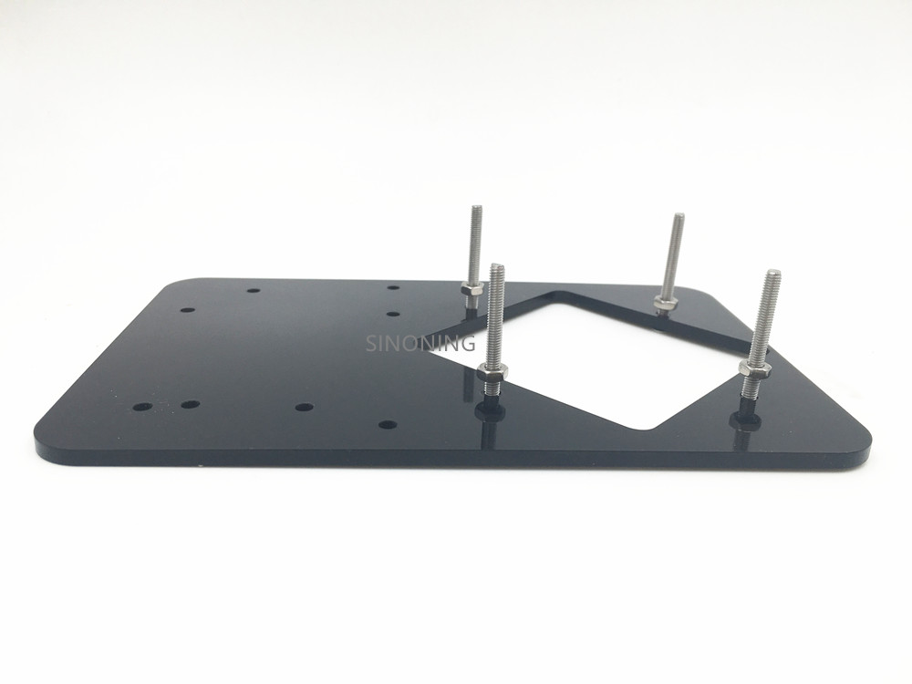

# 3.install pivot servo

2pcs  M3*9

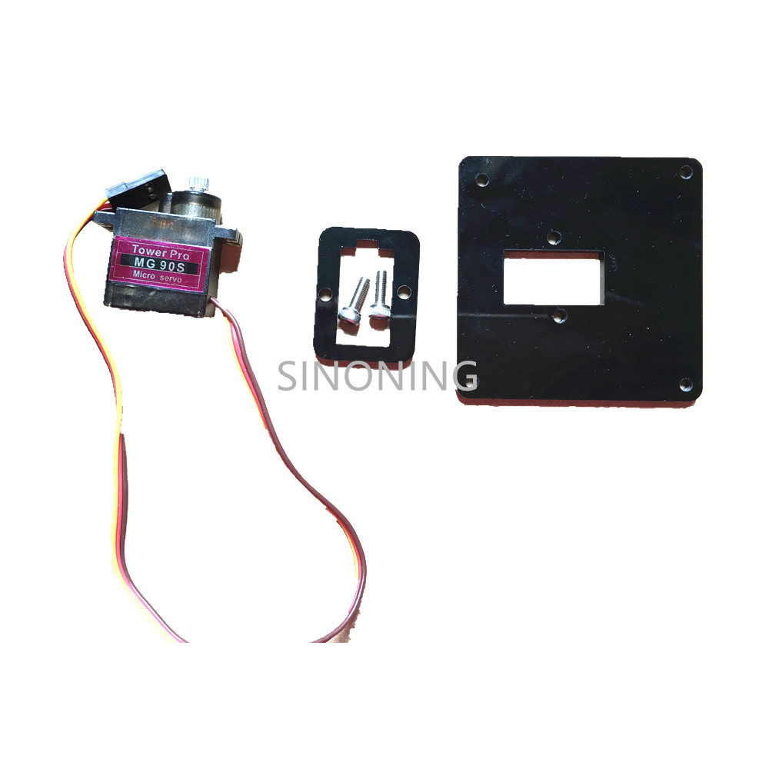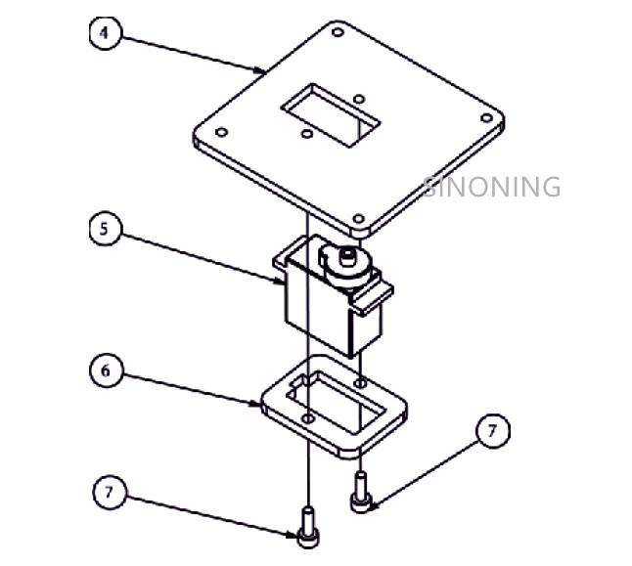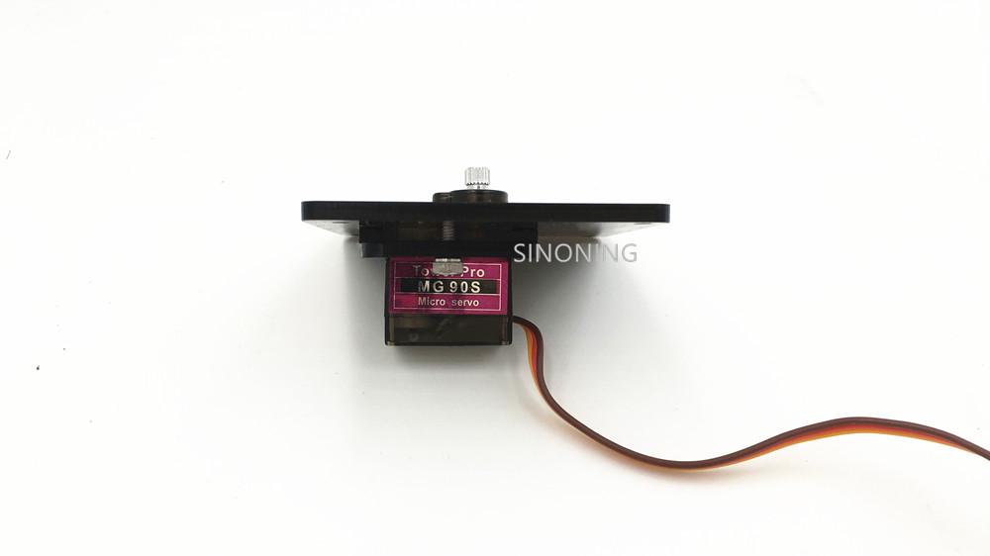

# 4. install servo on base plate

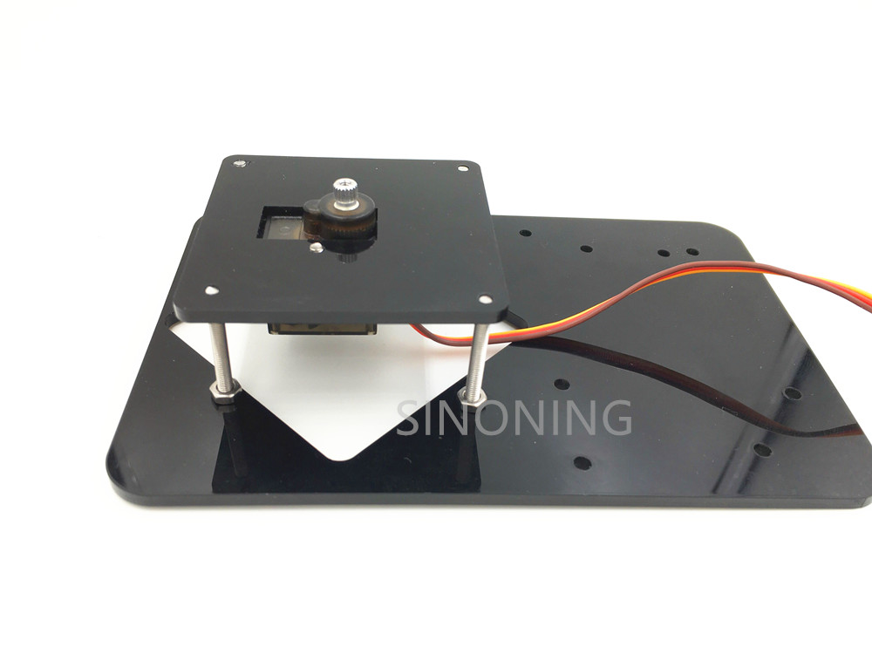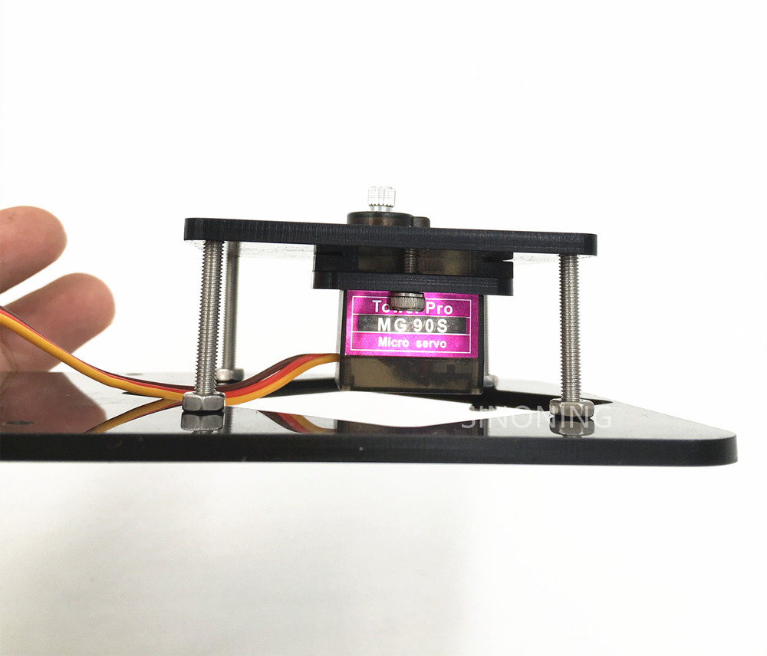

# 5.install the bottom acrylic plate to pivot servo

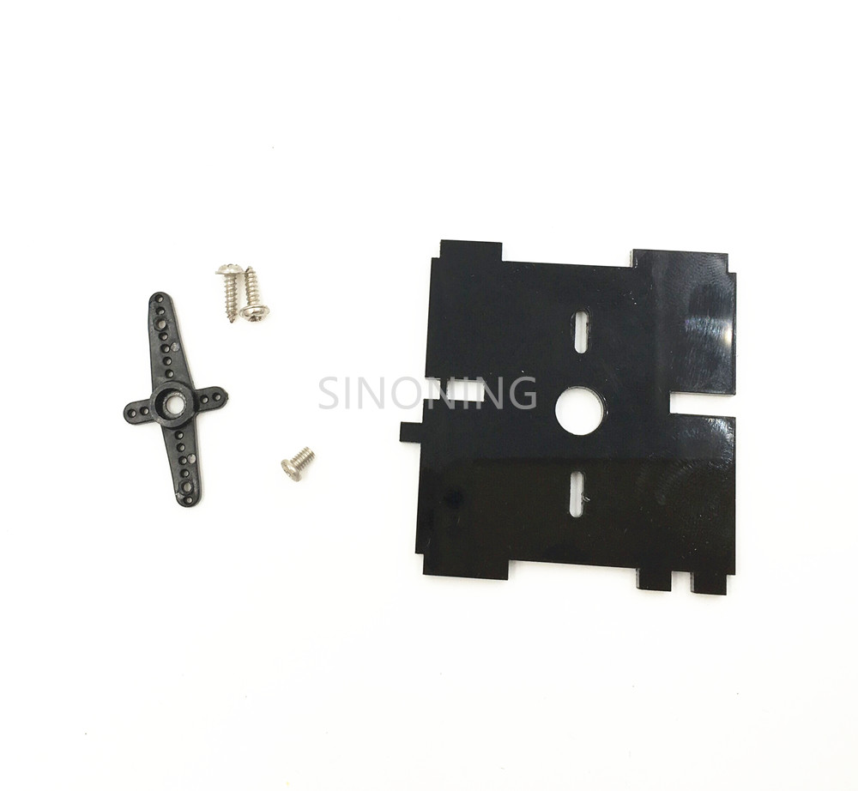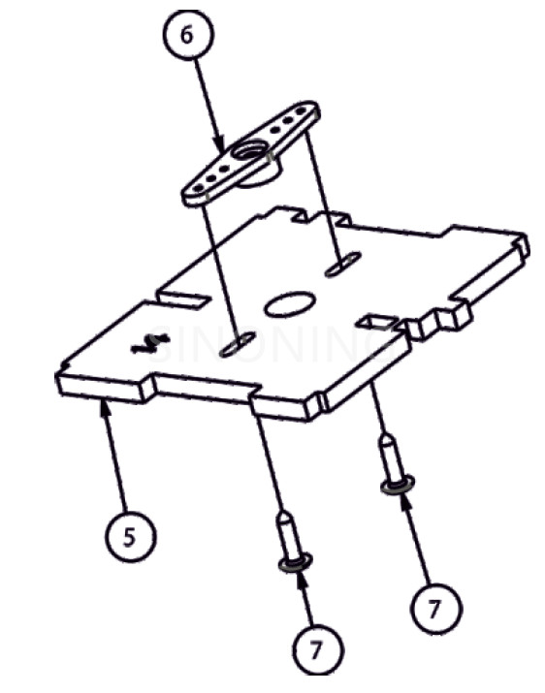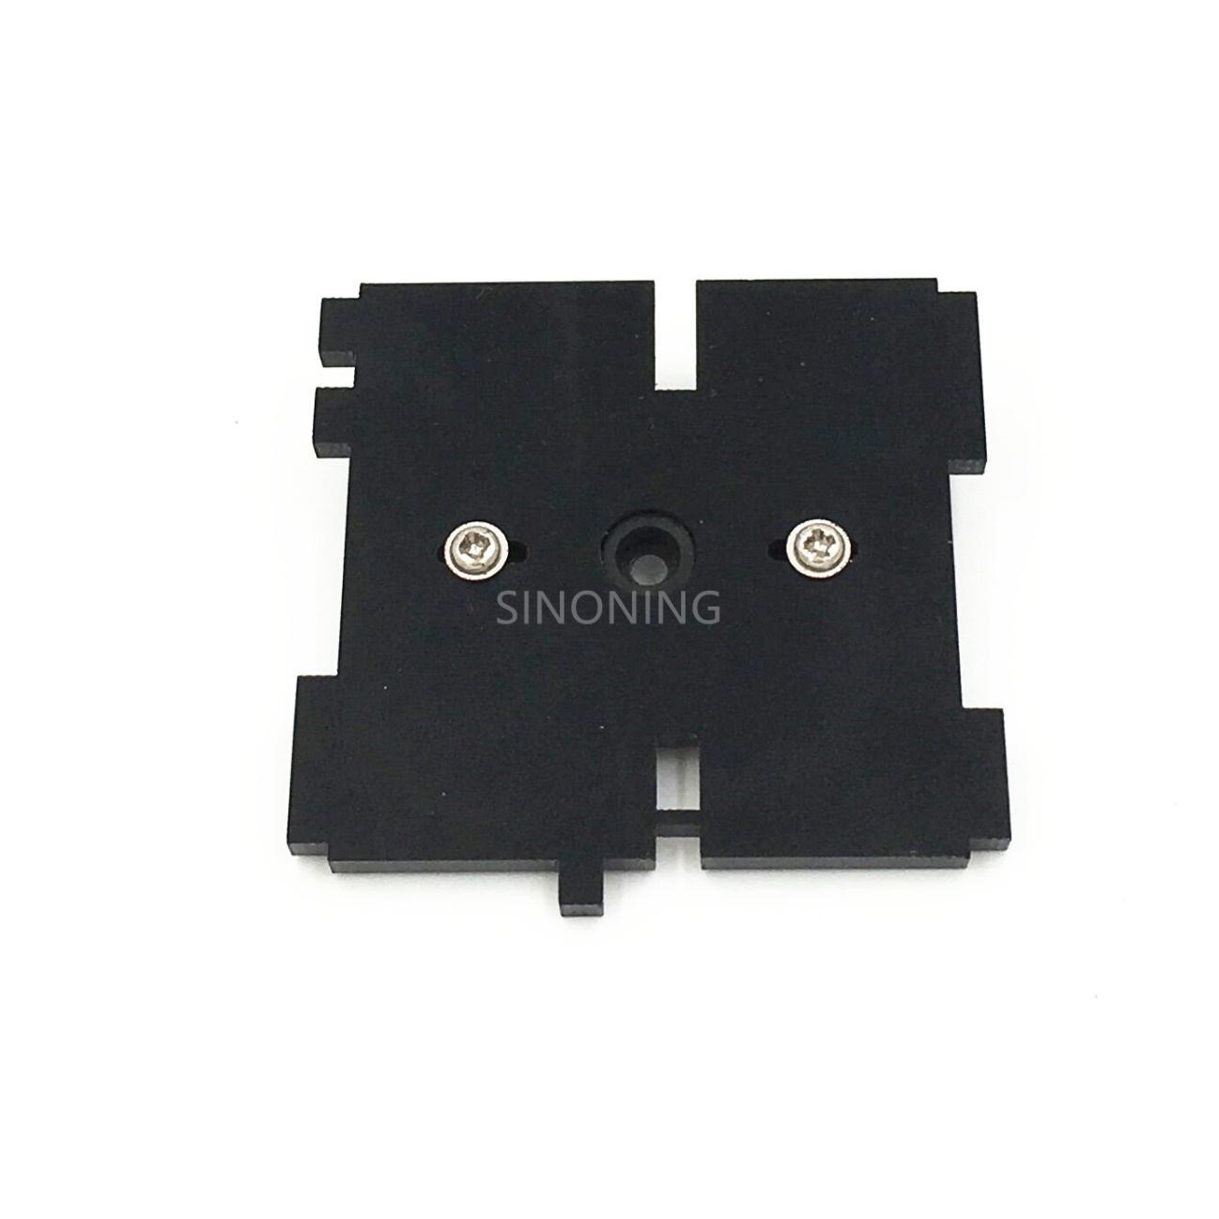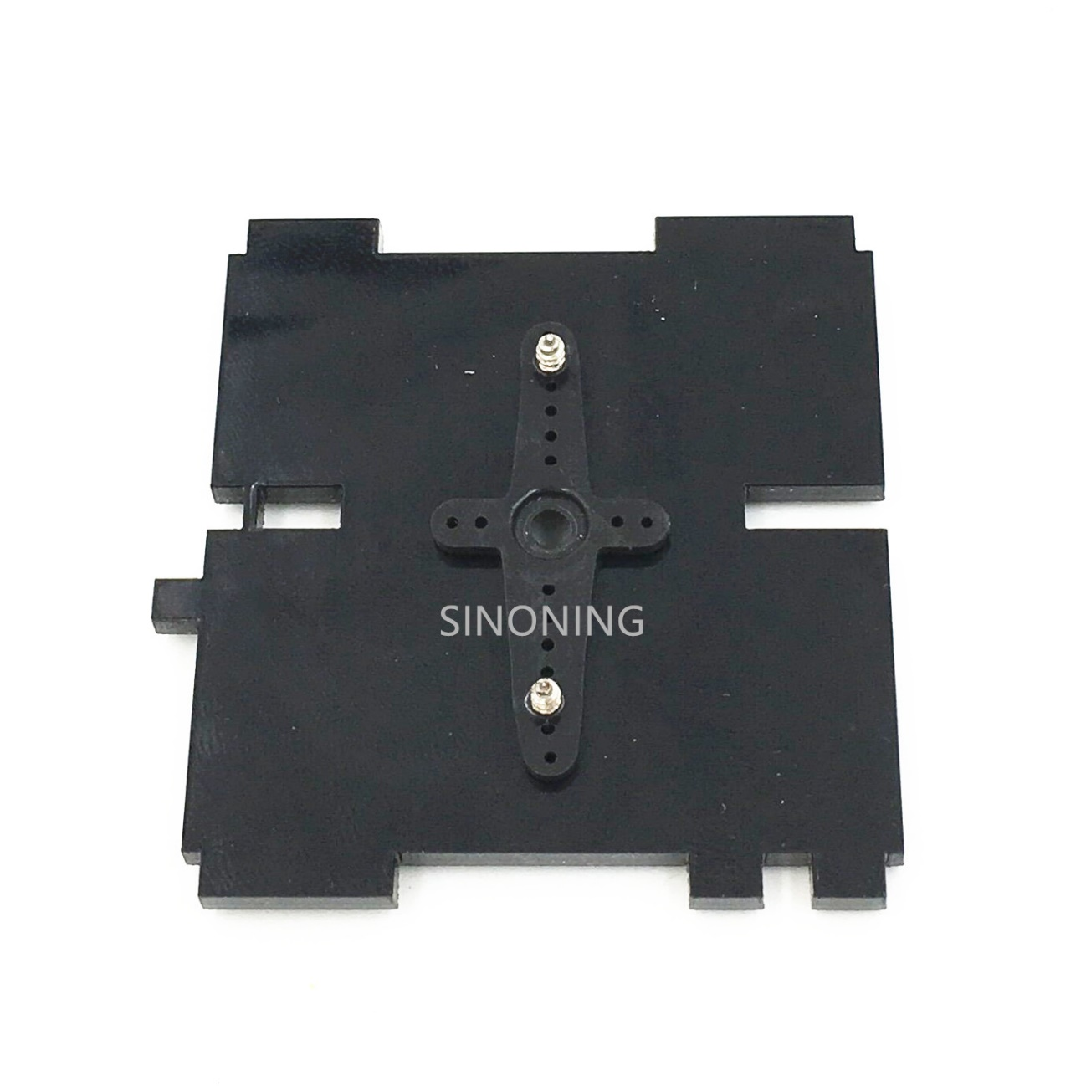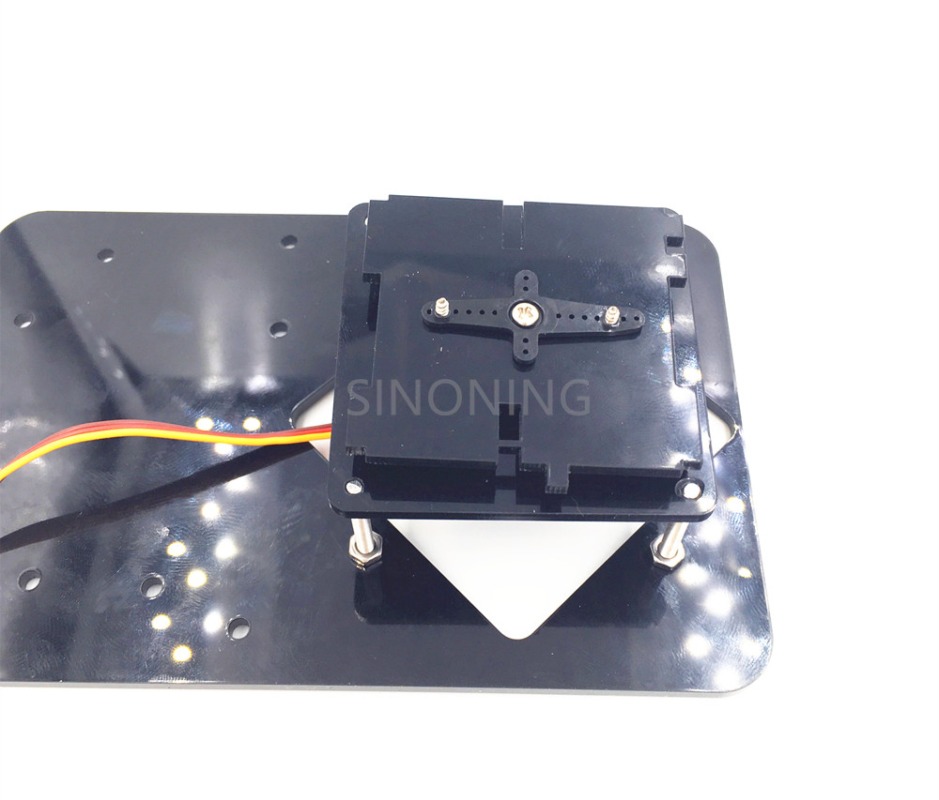

# 6. install left arm servo

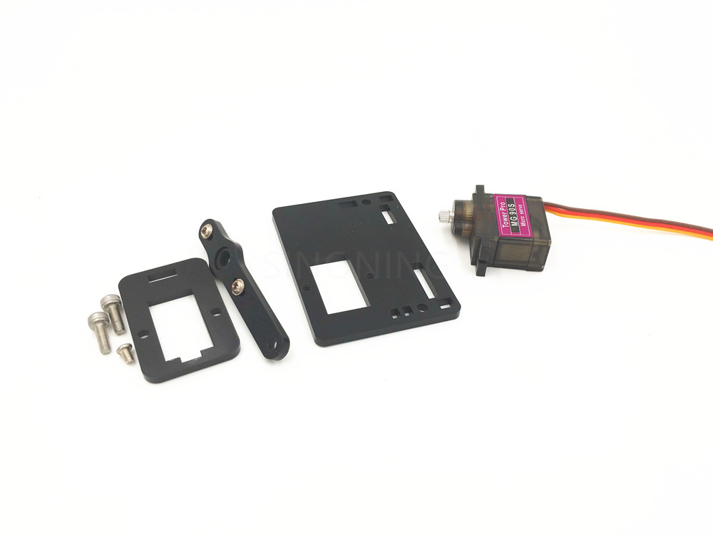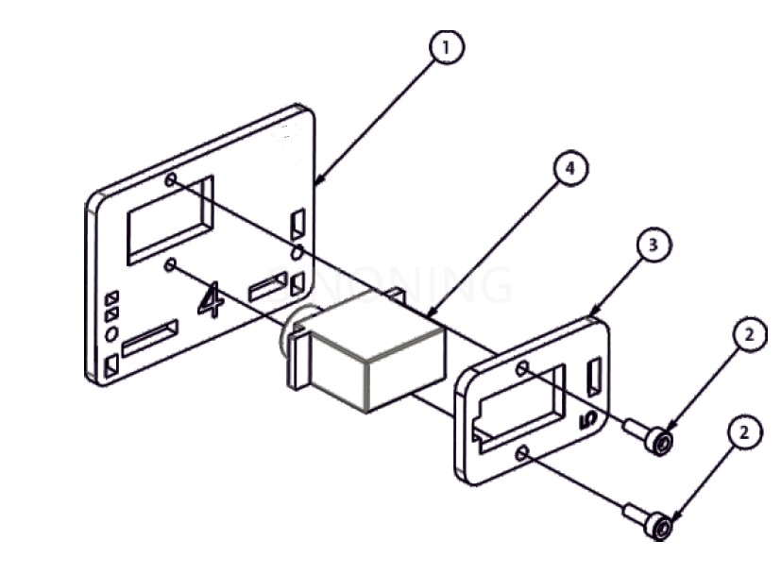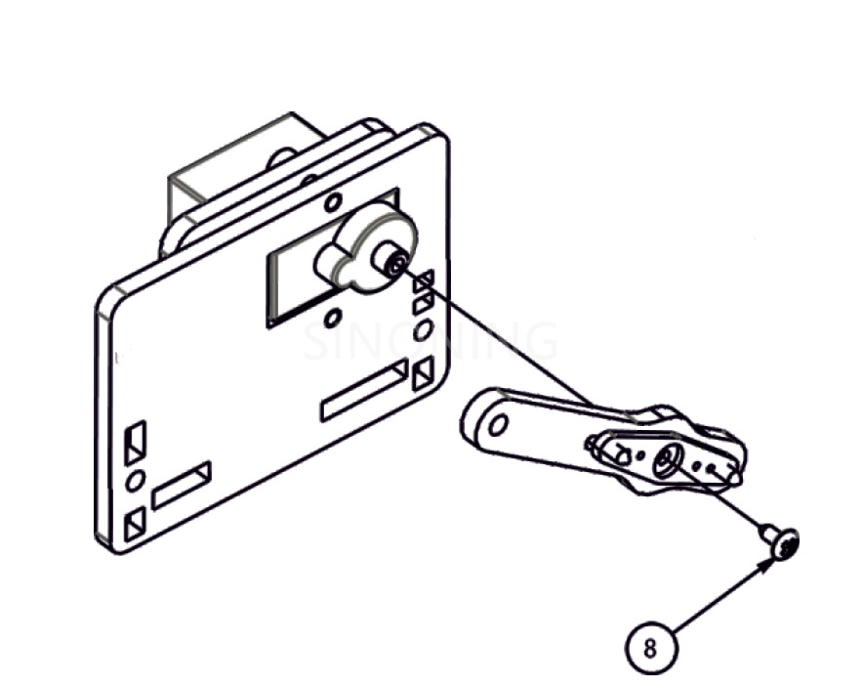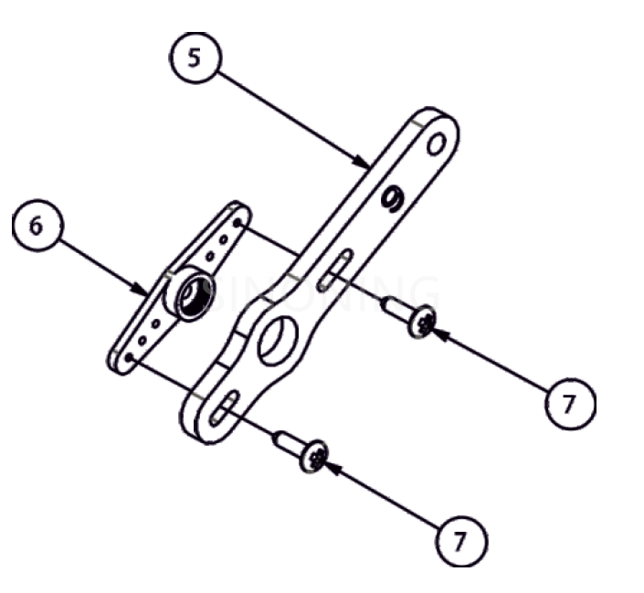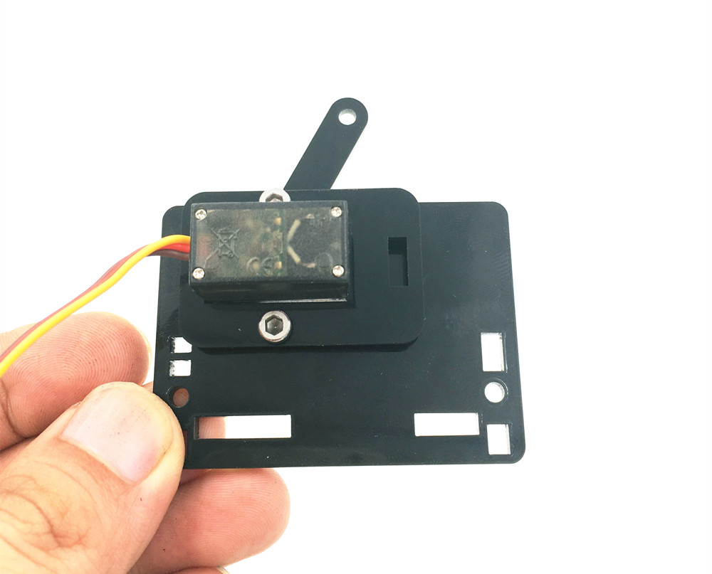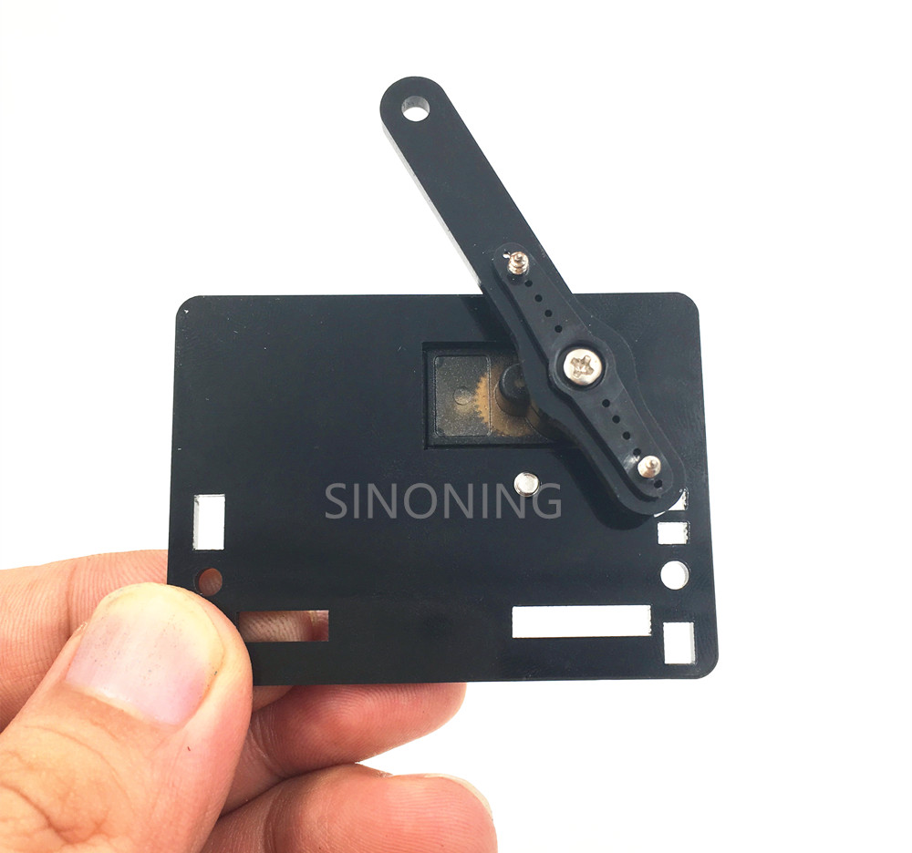

# 7. install right Arm Servo on right plate

2psc  M3*9

1pcs  M3*6

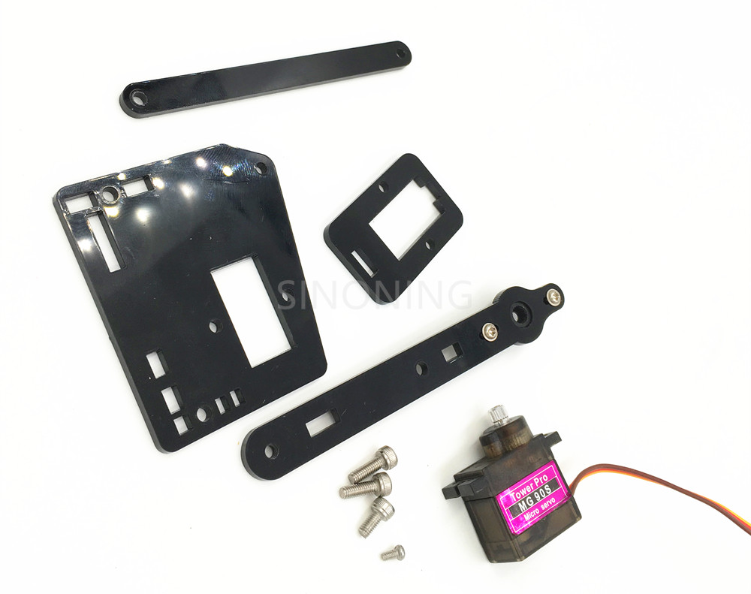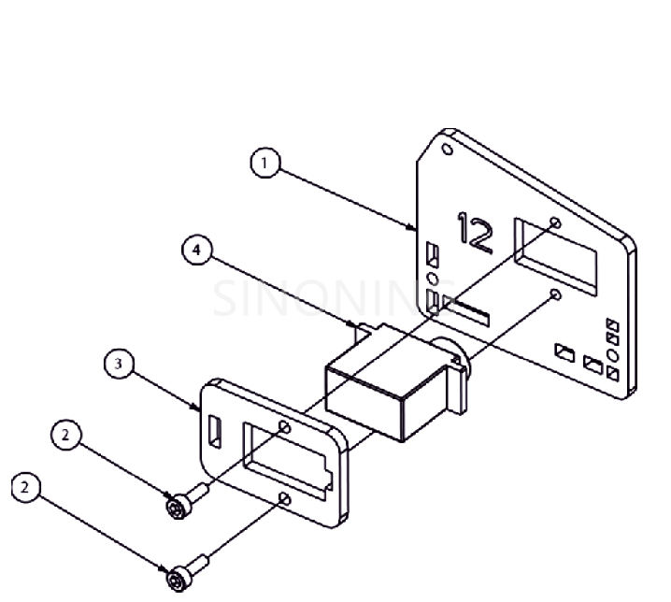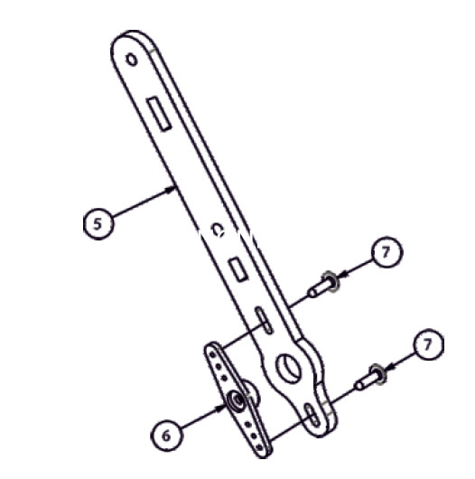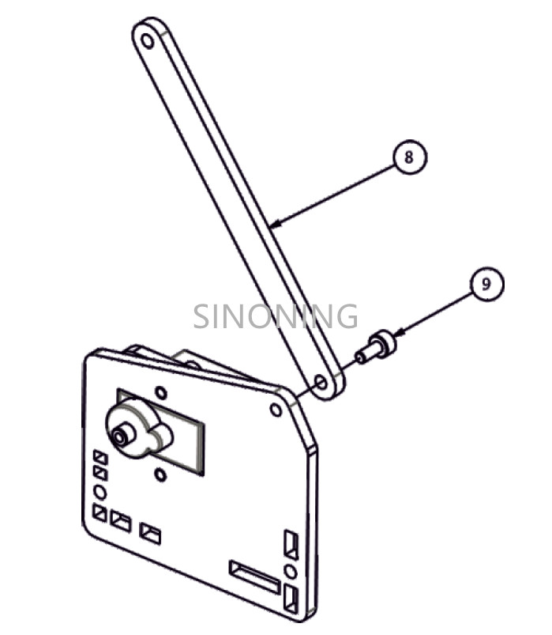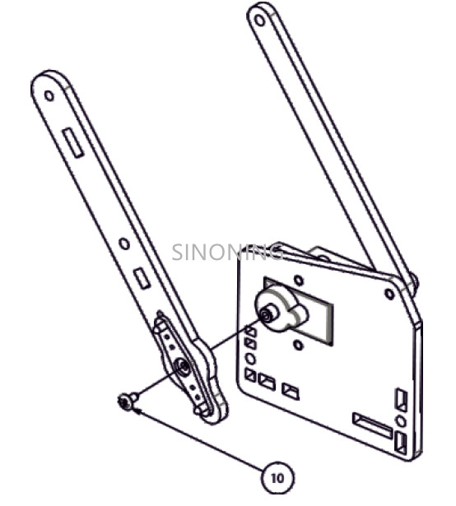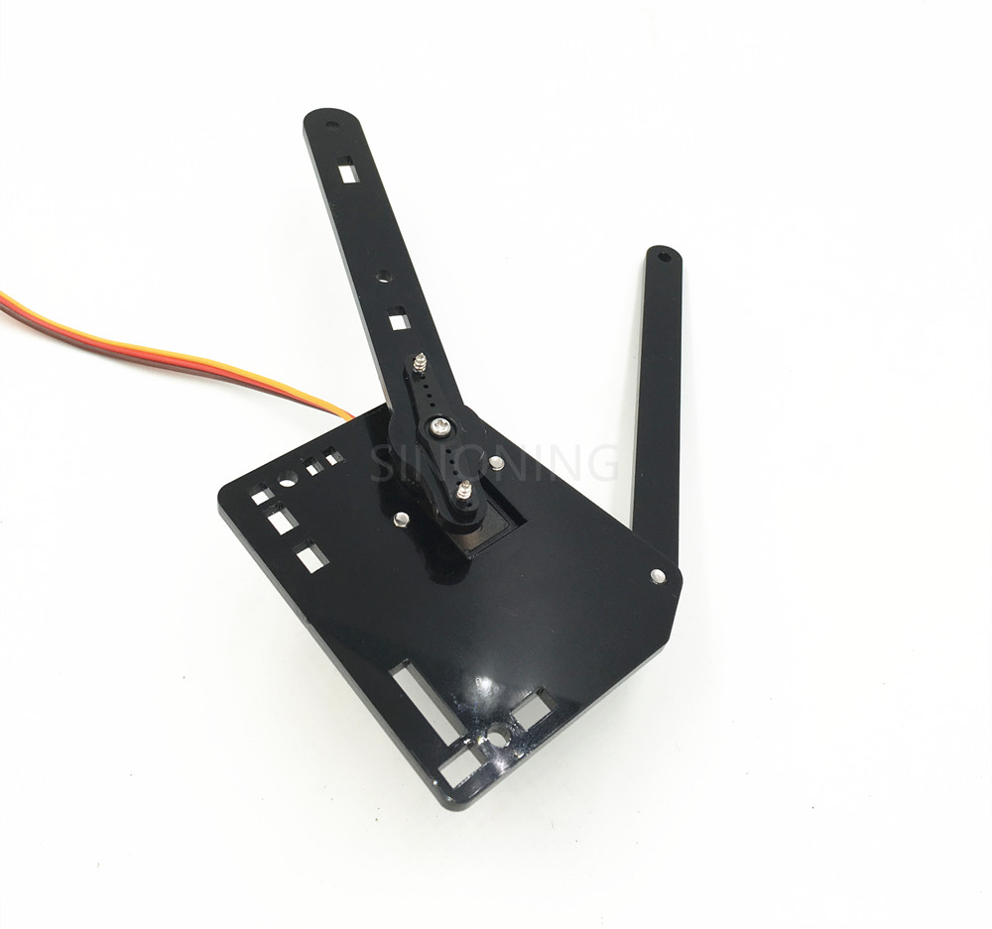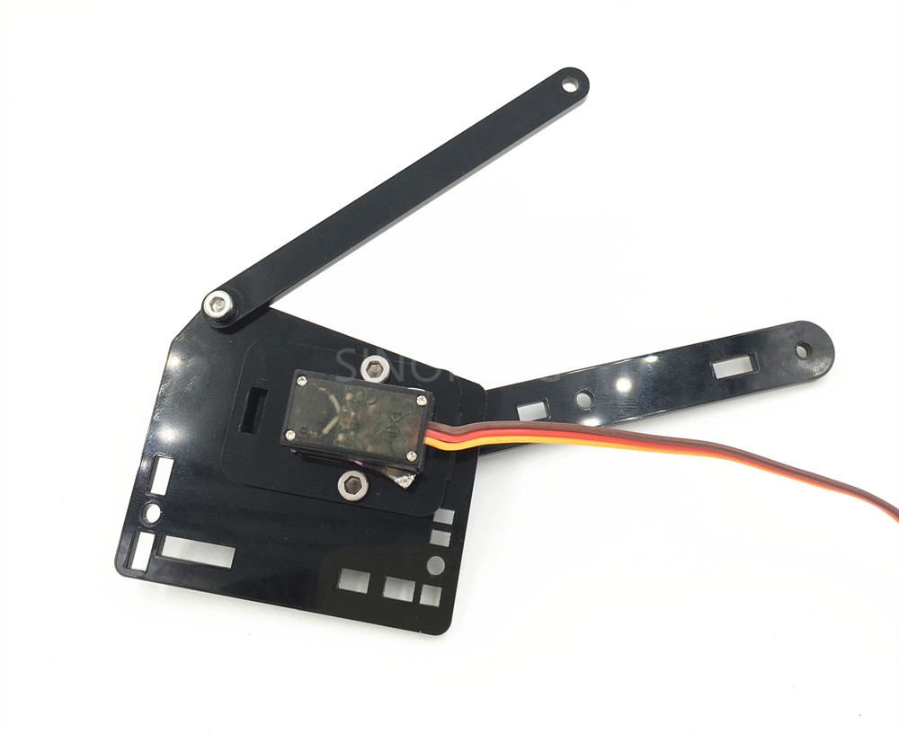

# 8. install center base plate join

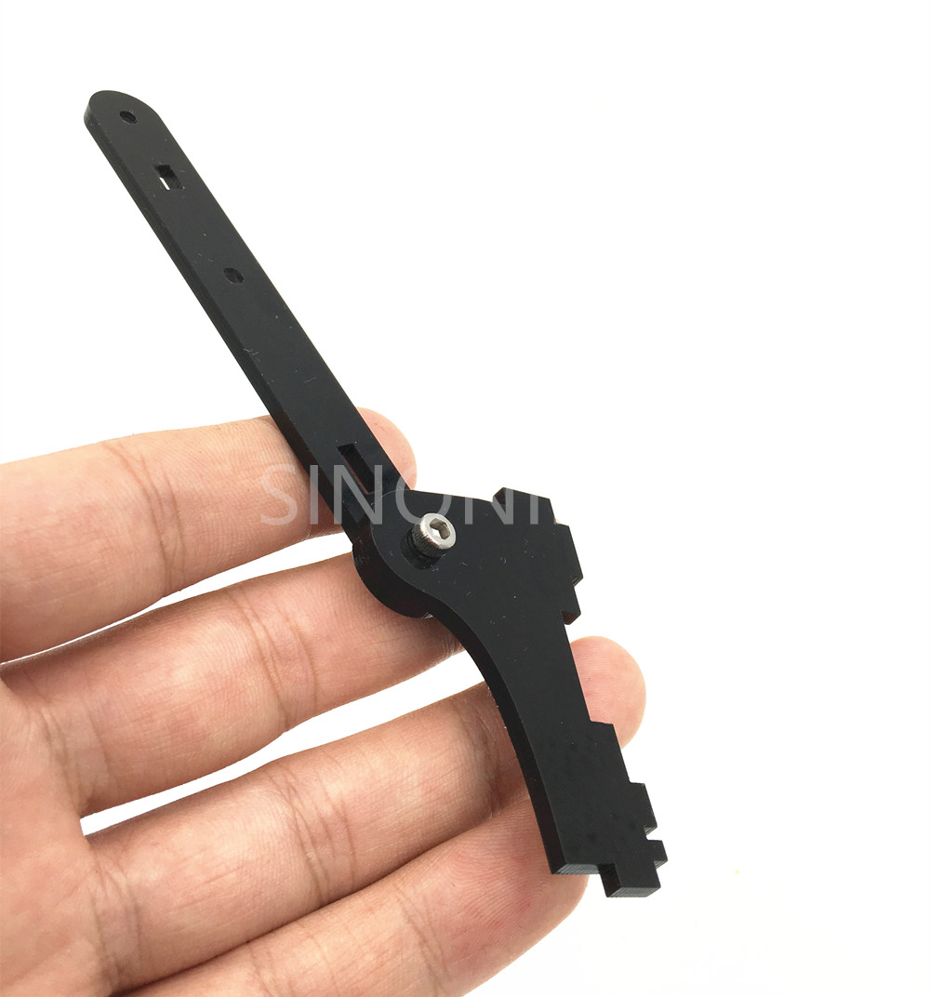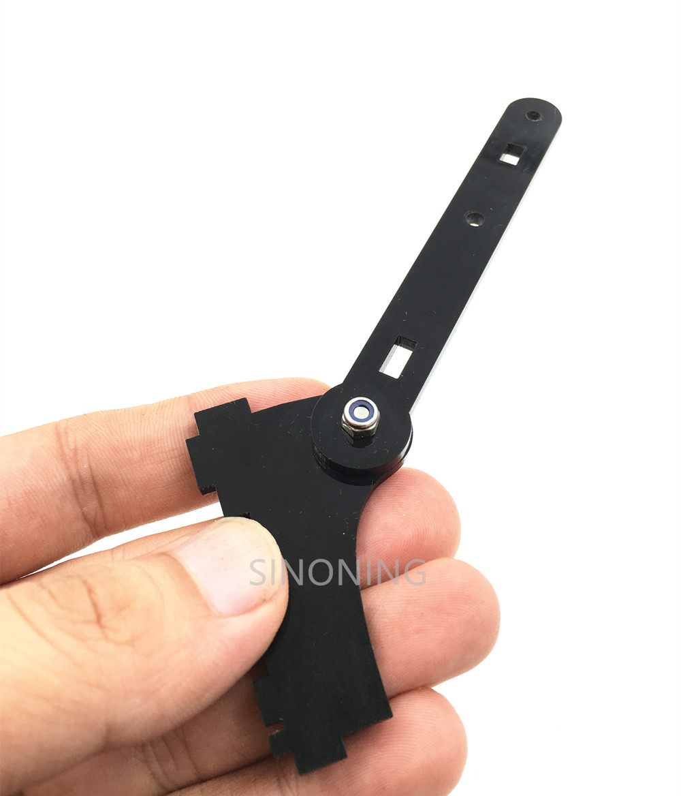

# 9. connect the hull

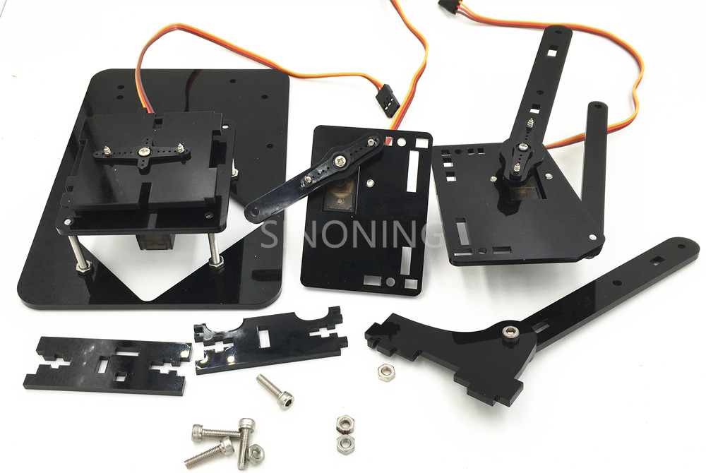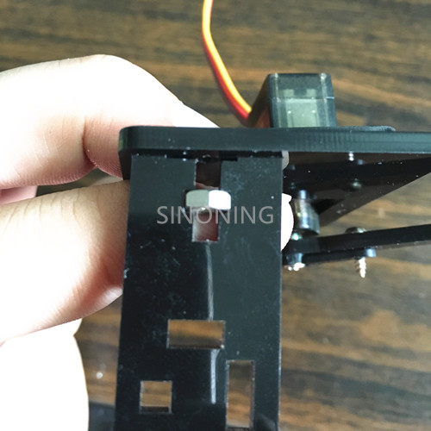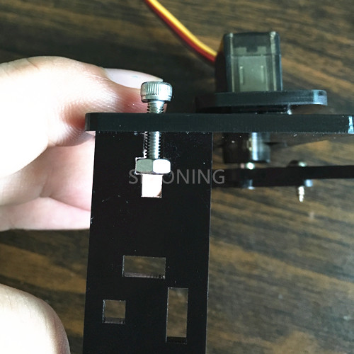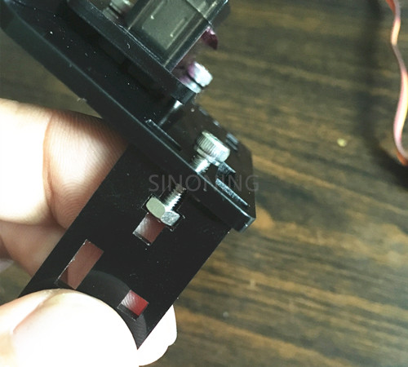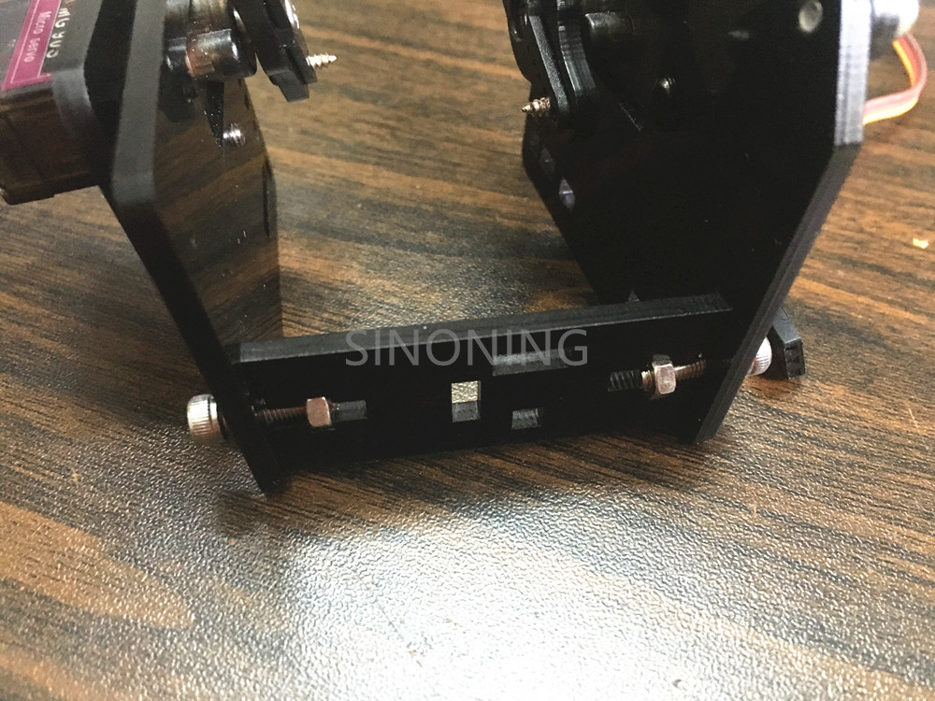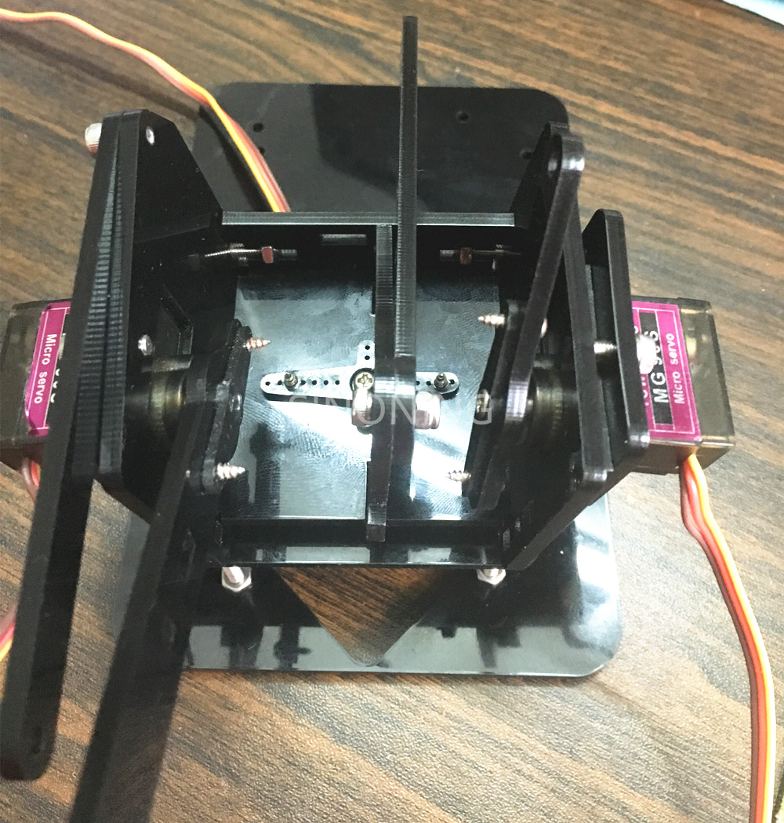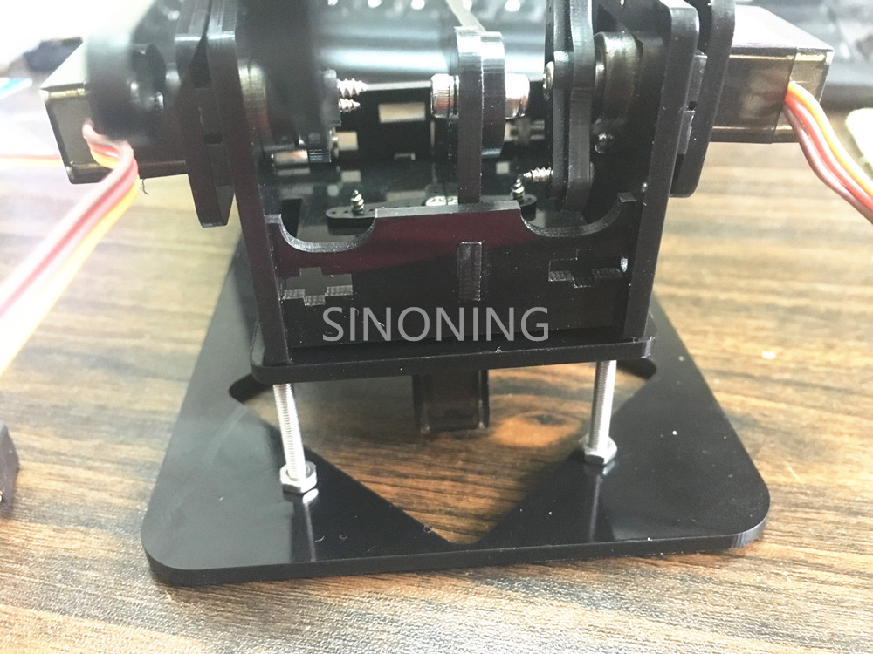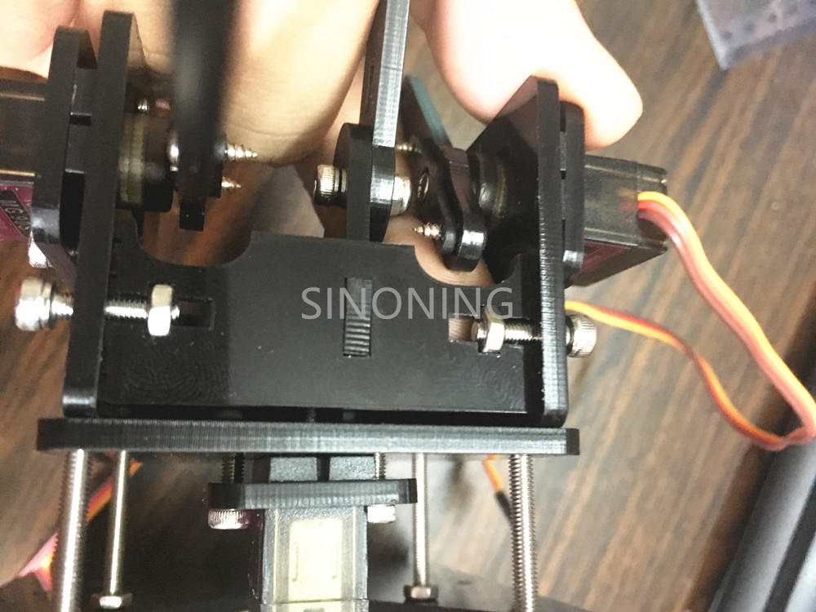

# 10, install main arm

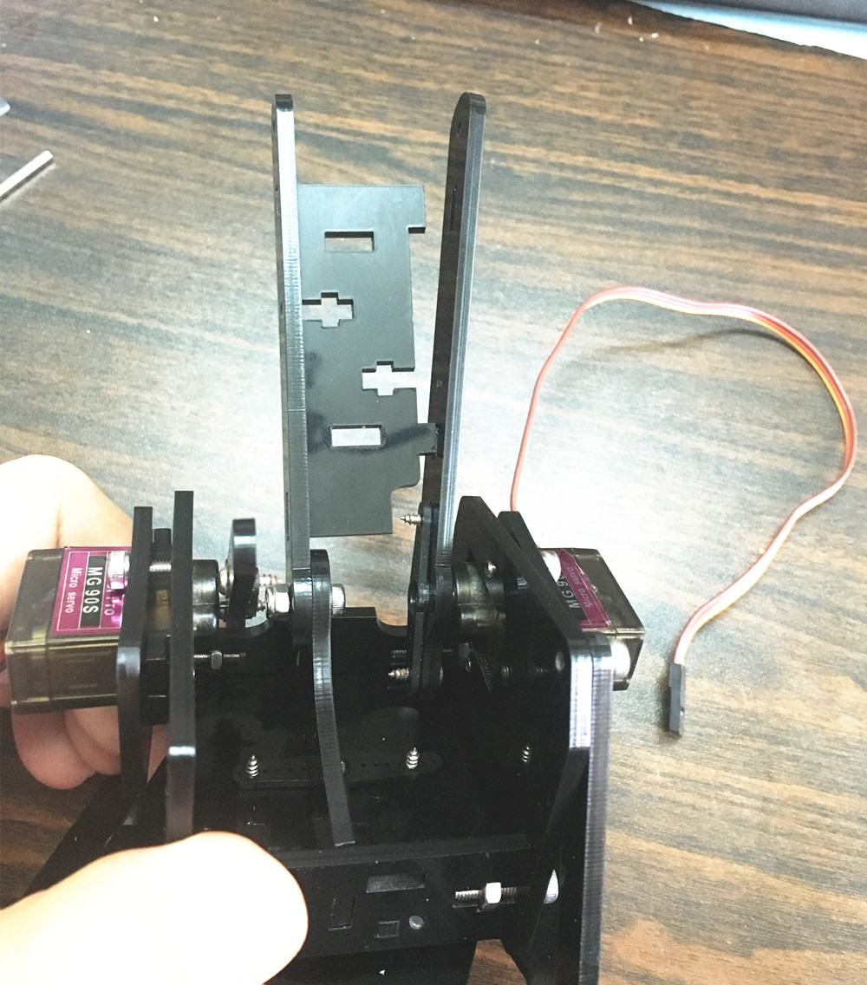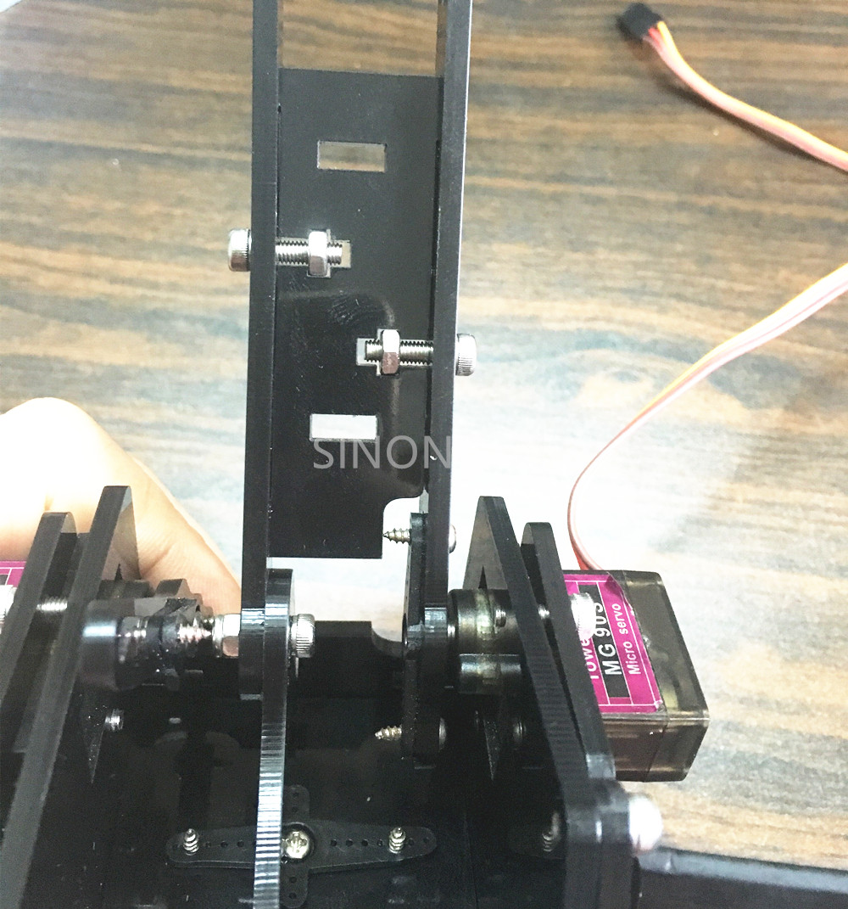

# 11, install small arm

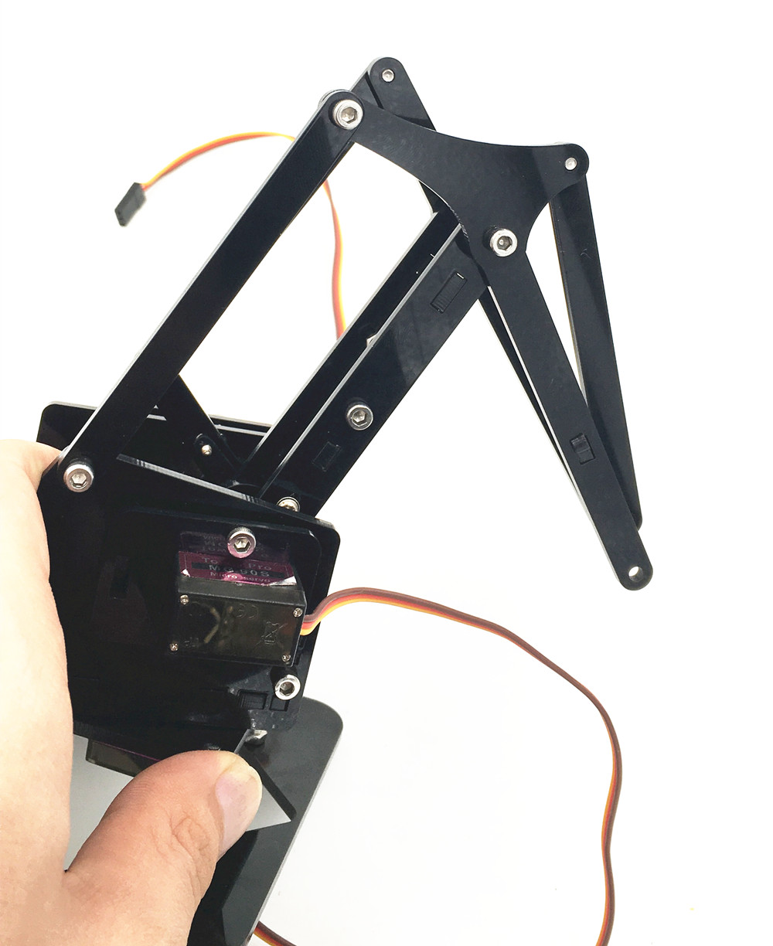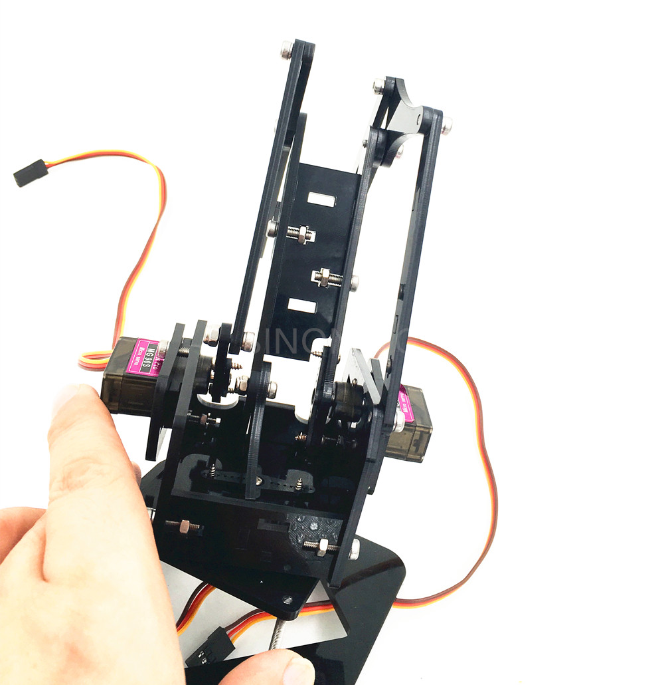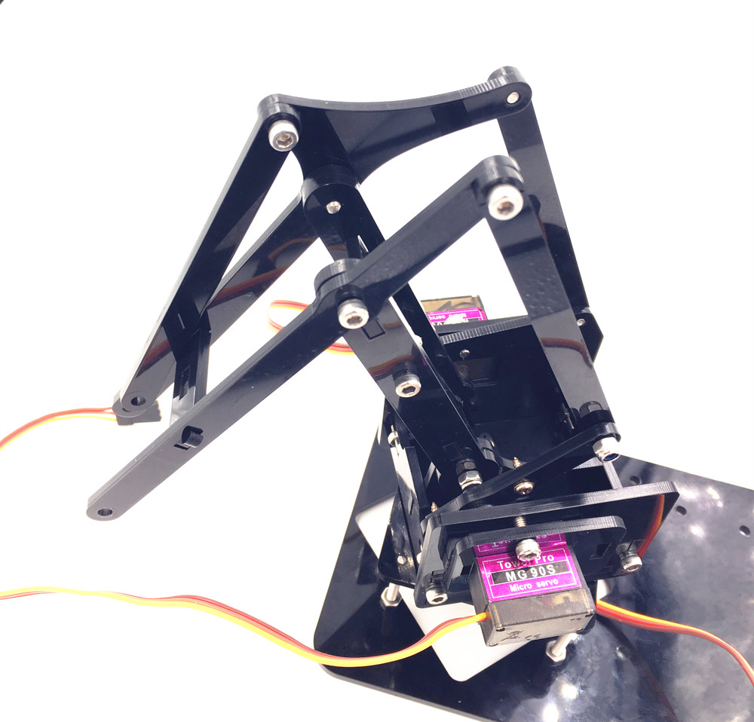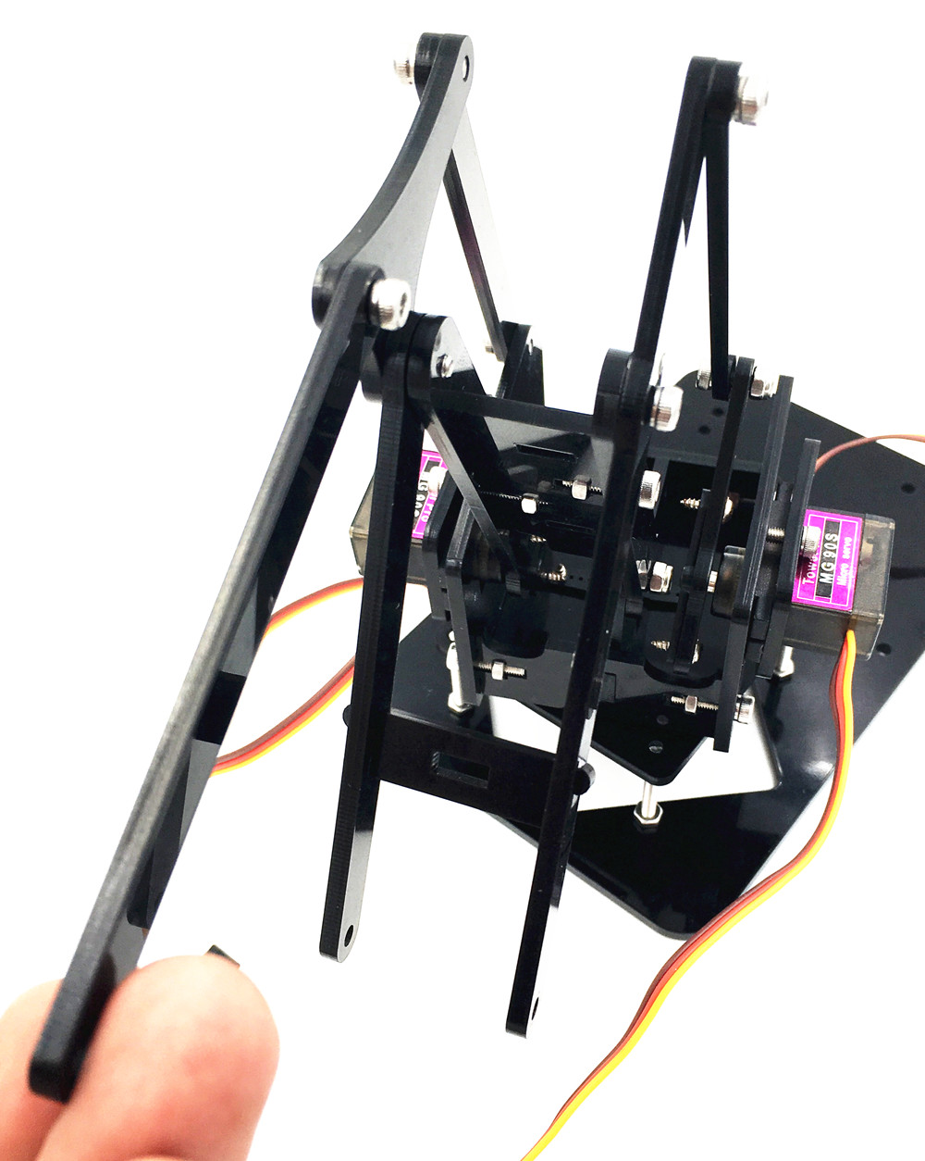

# 12.install grap

install base

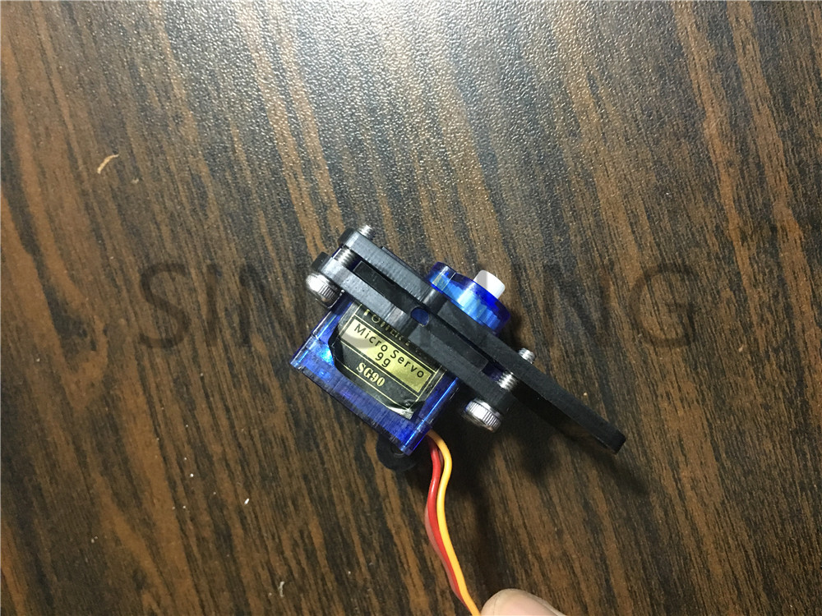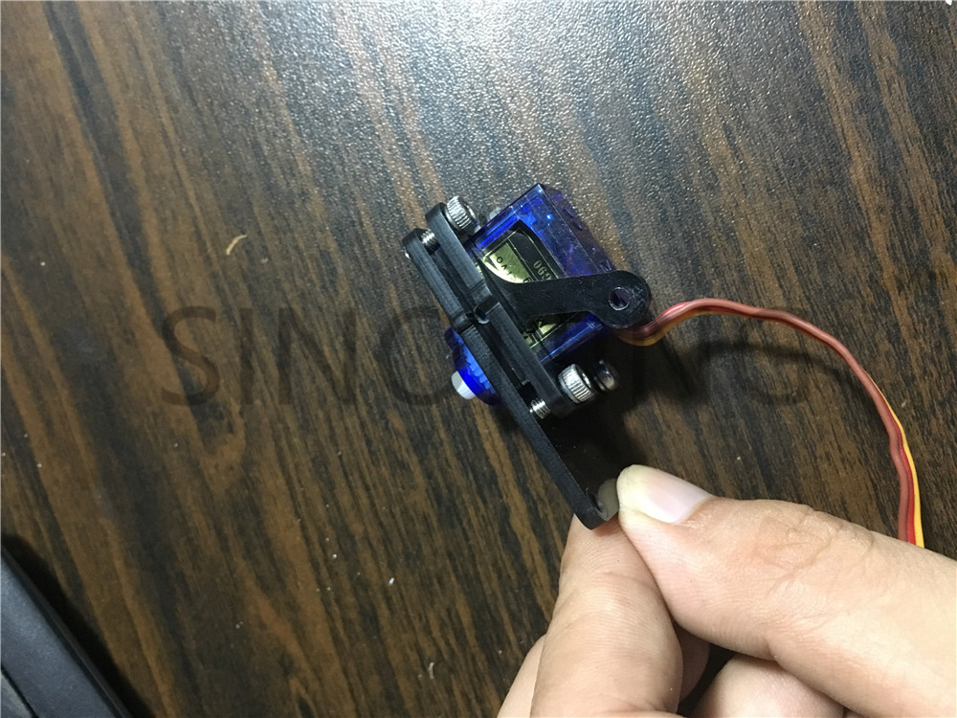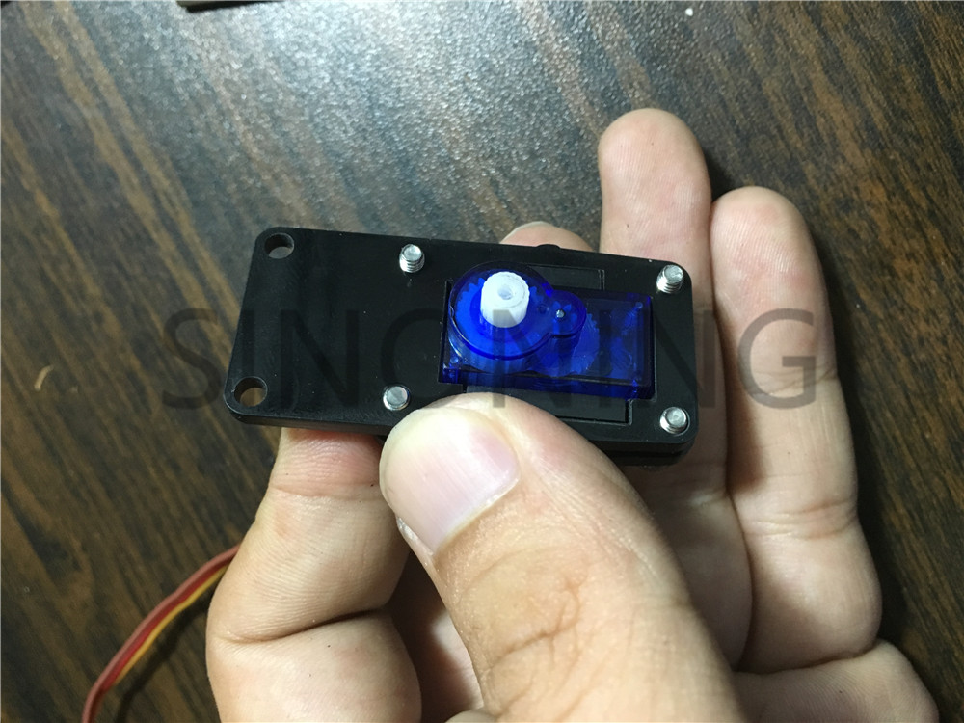

install grab

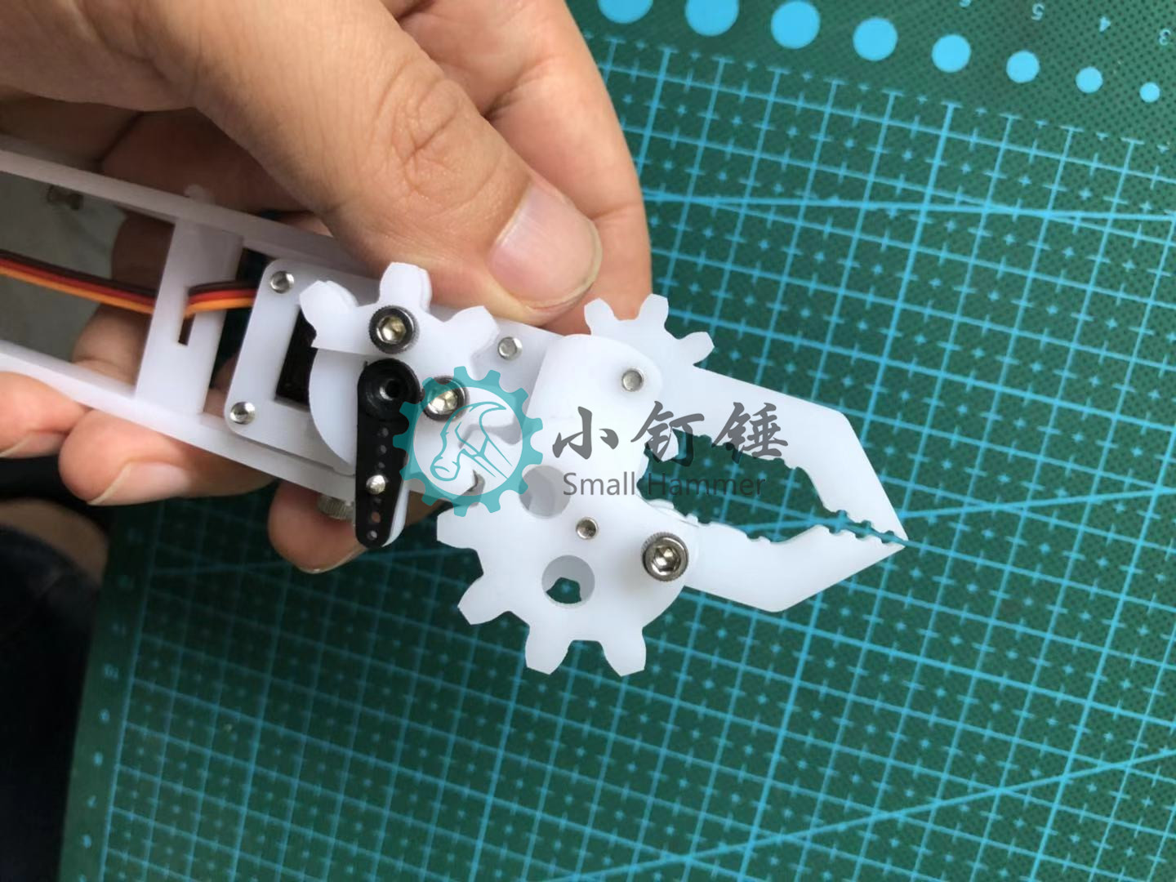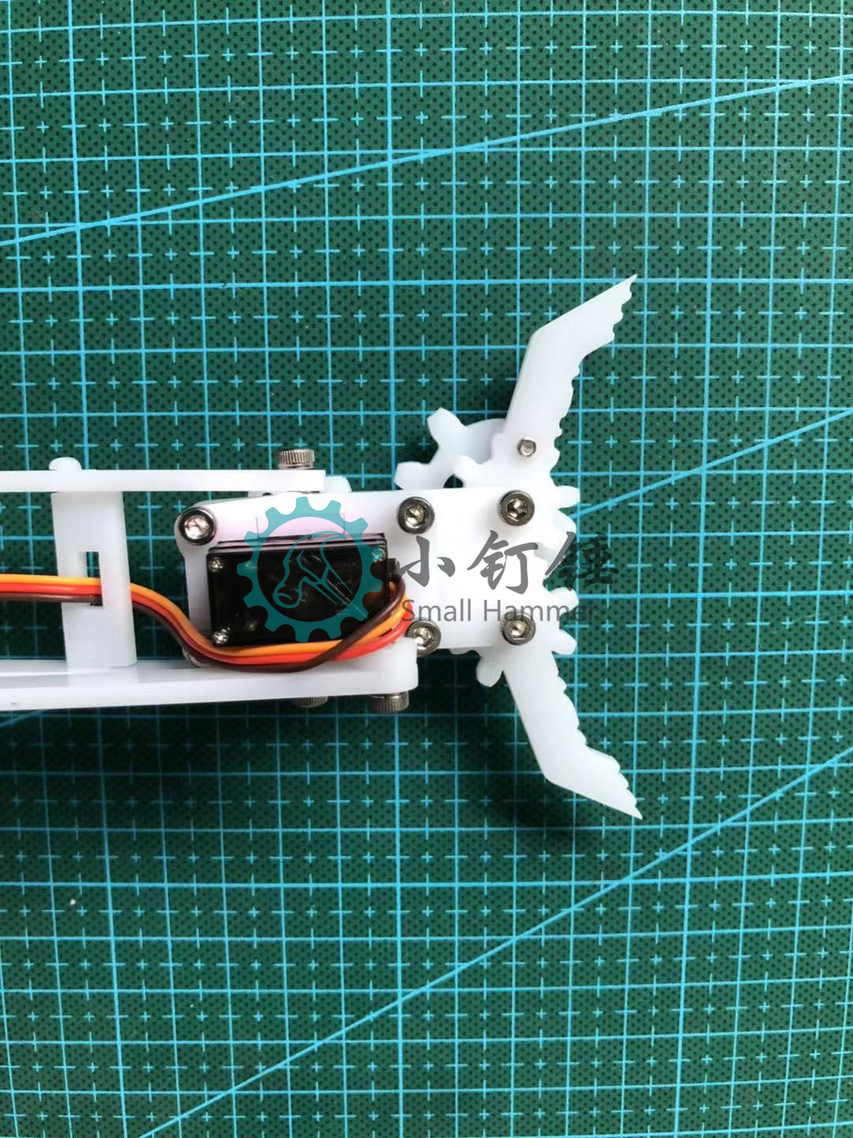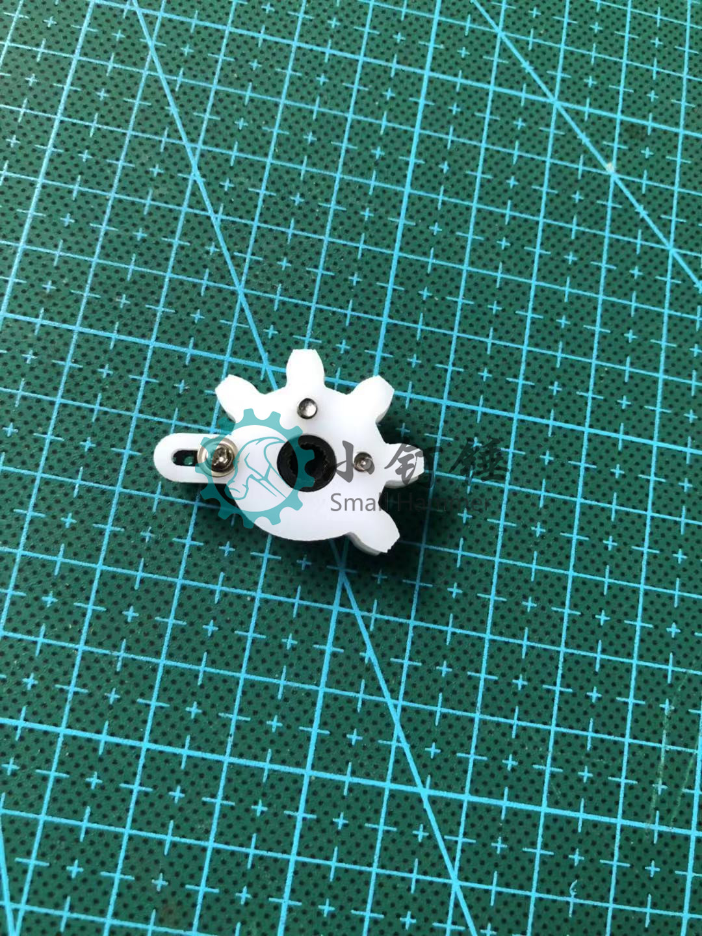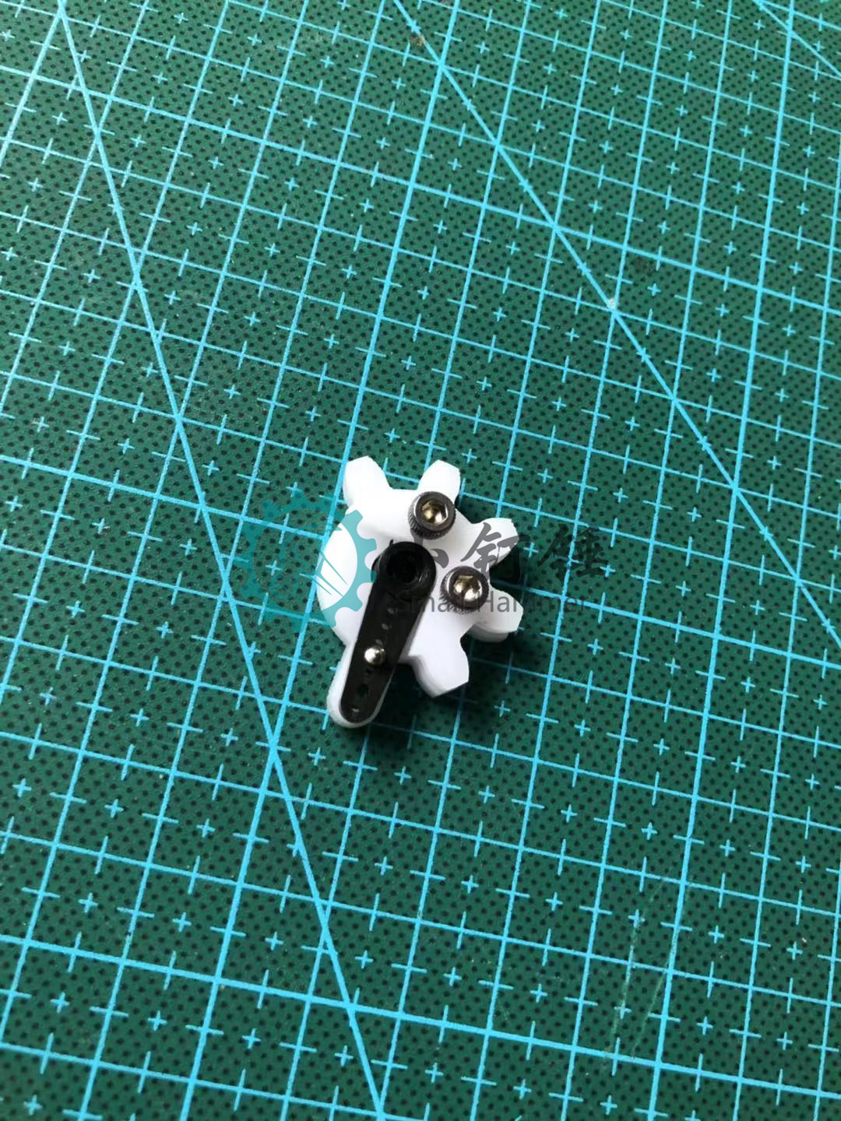

use the only one m3X9 screw

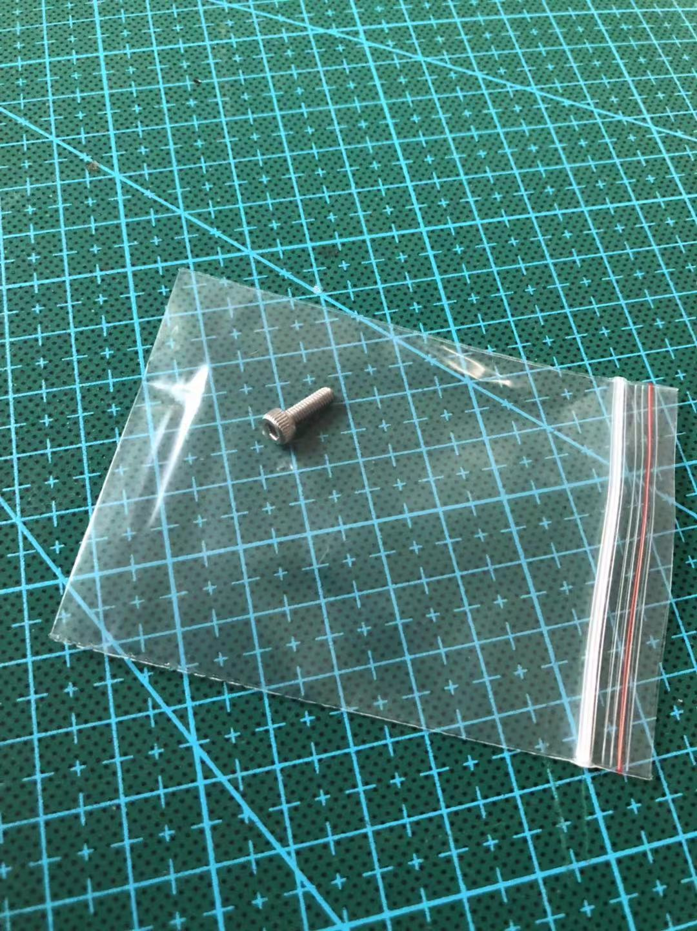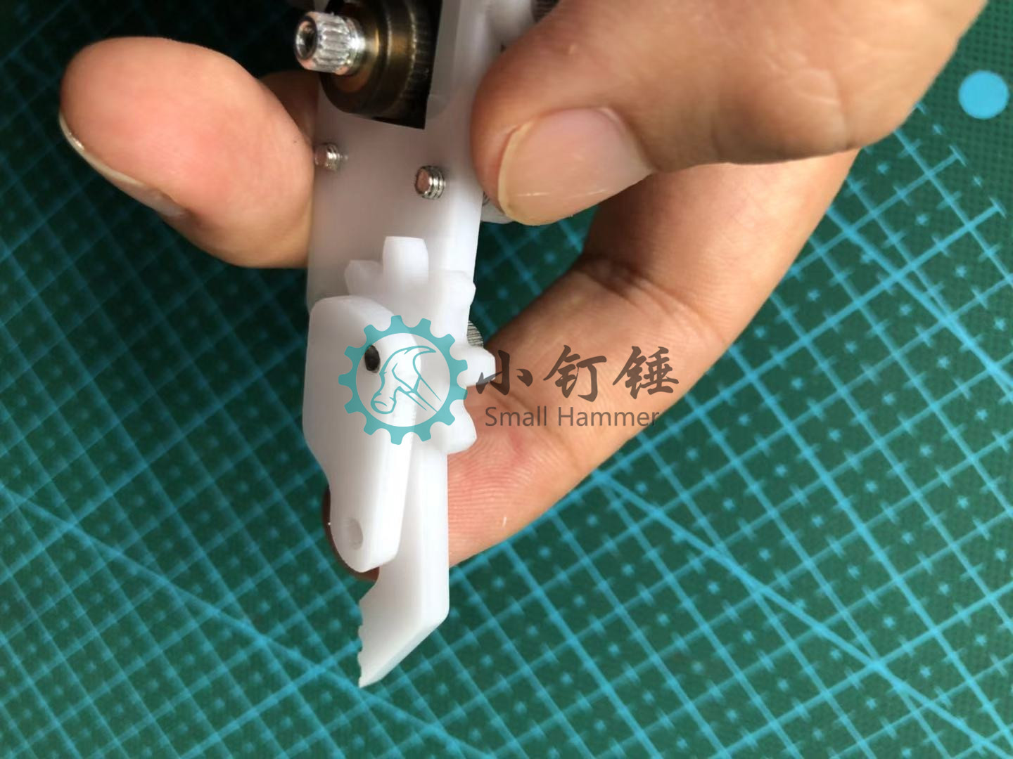

………………………………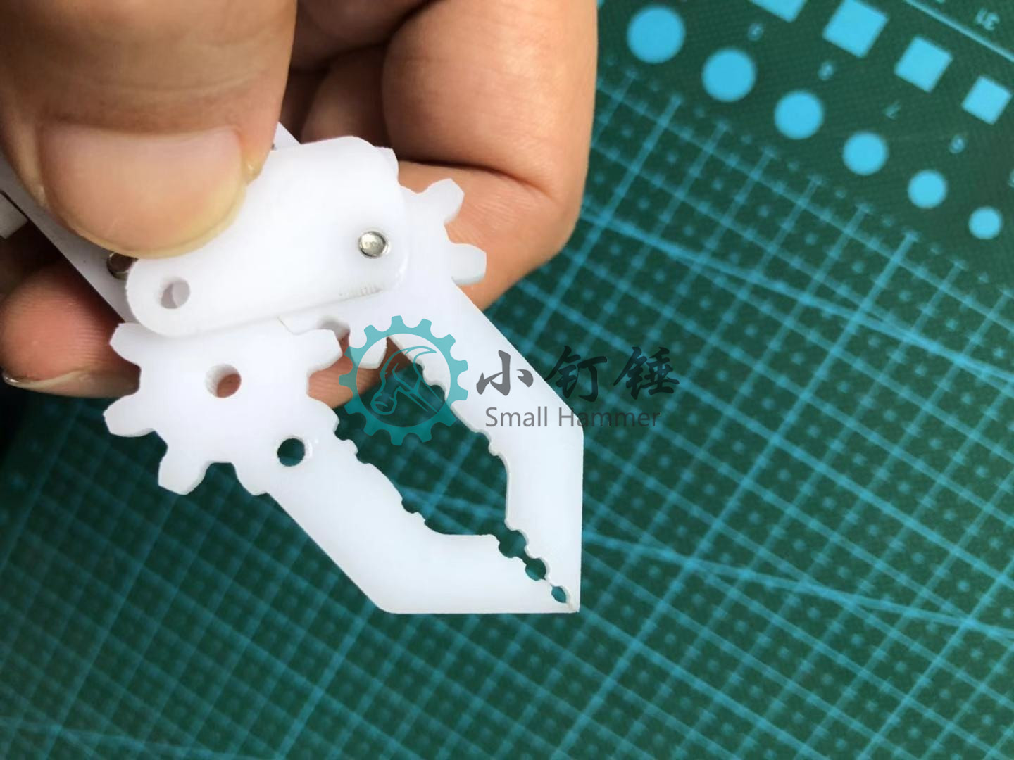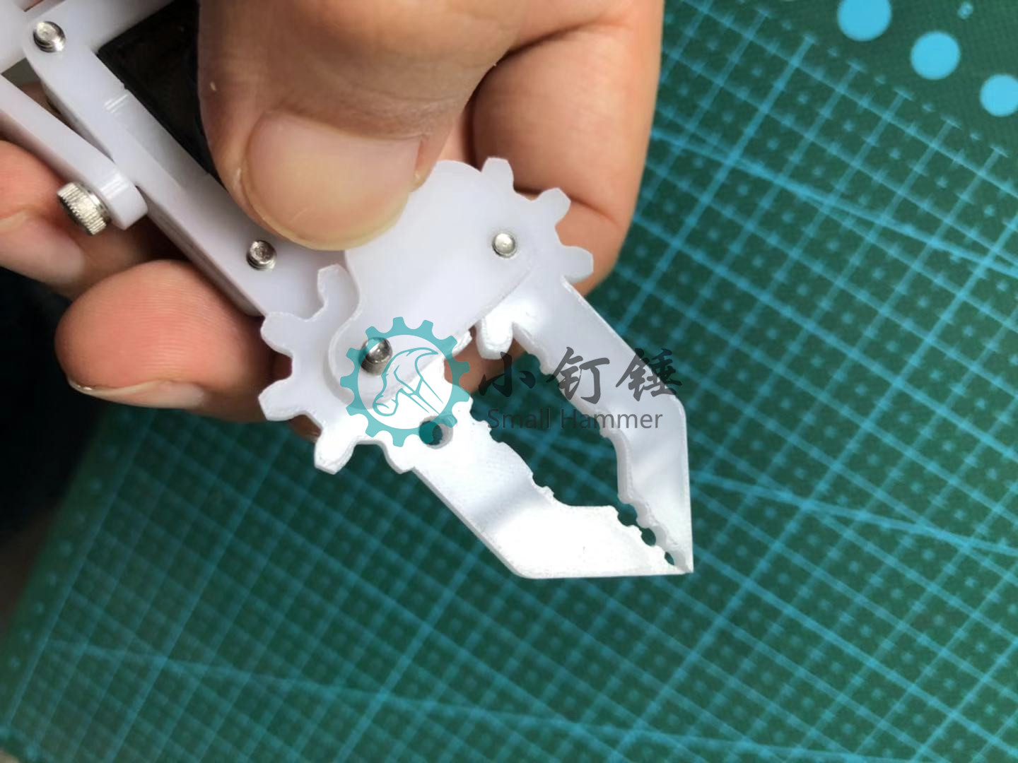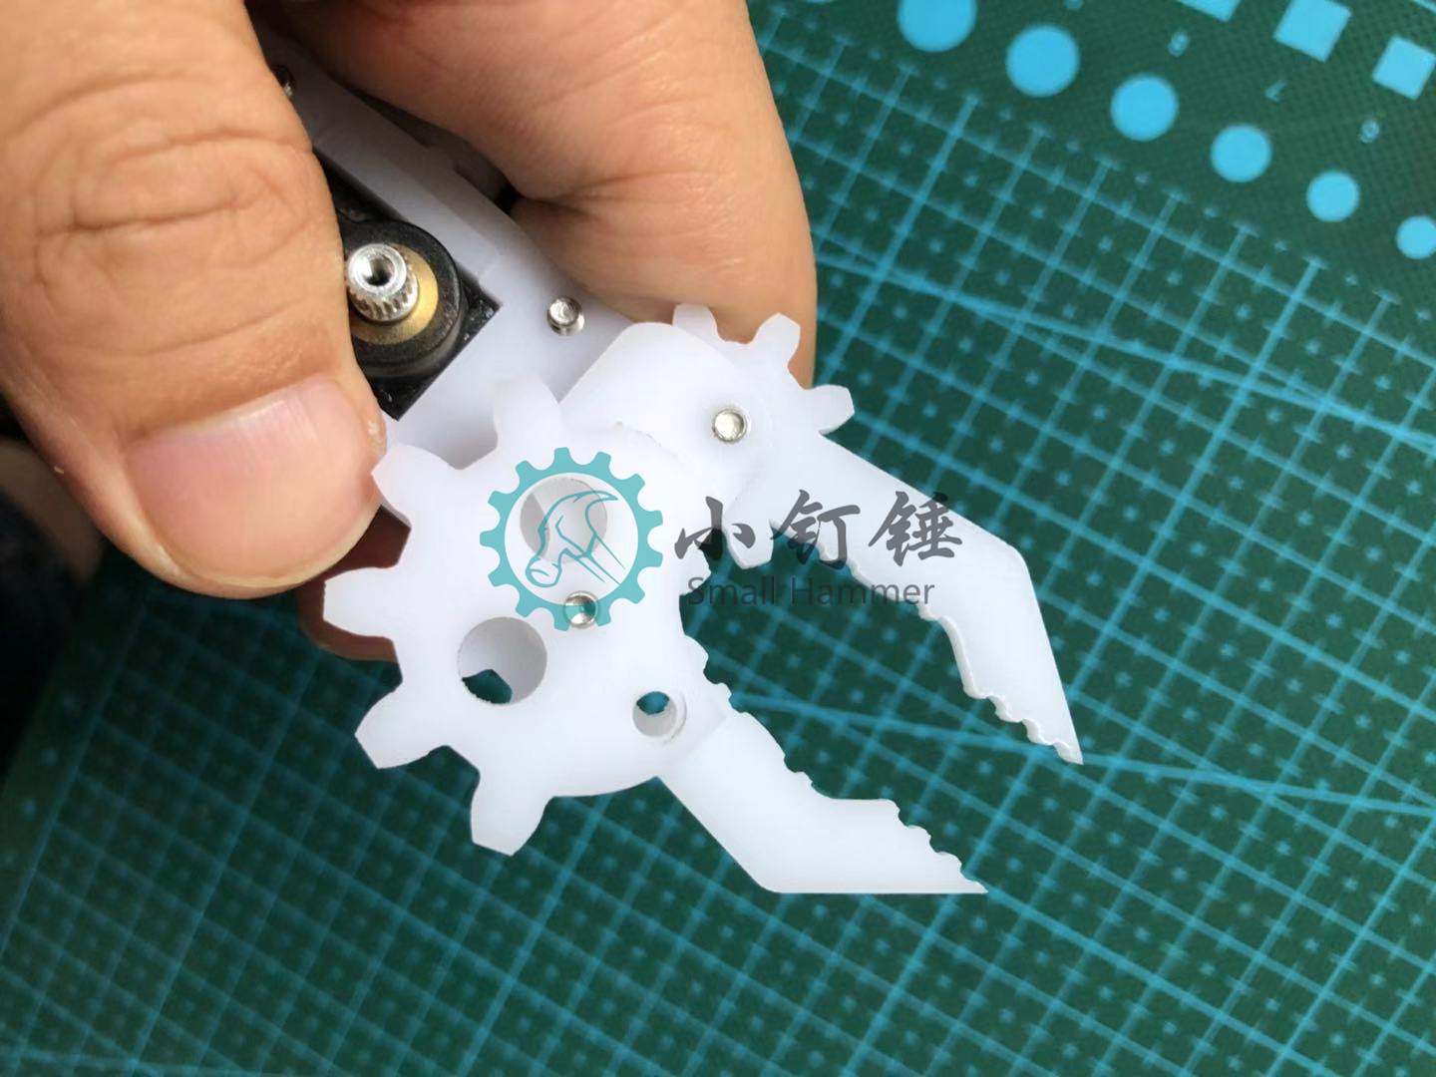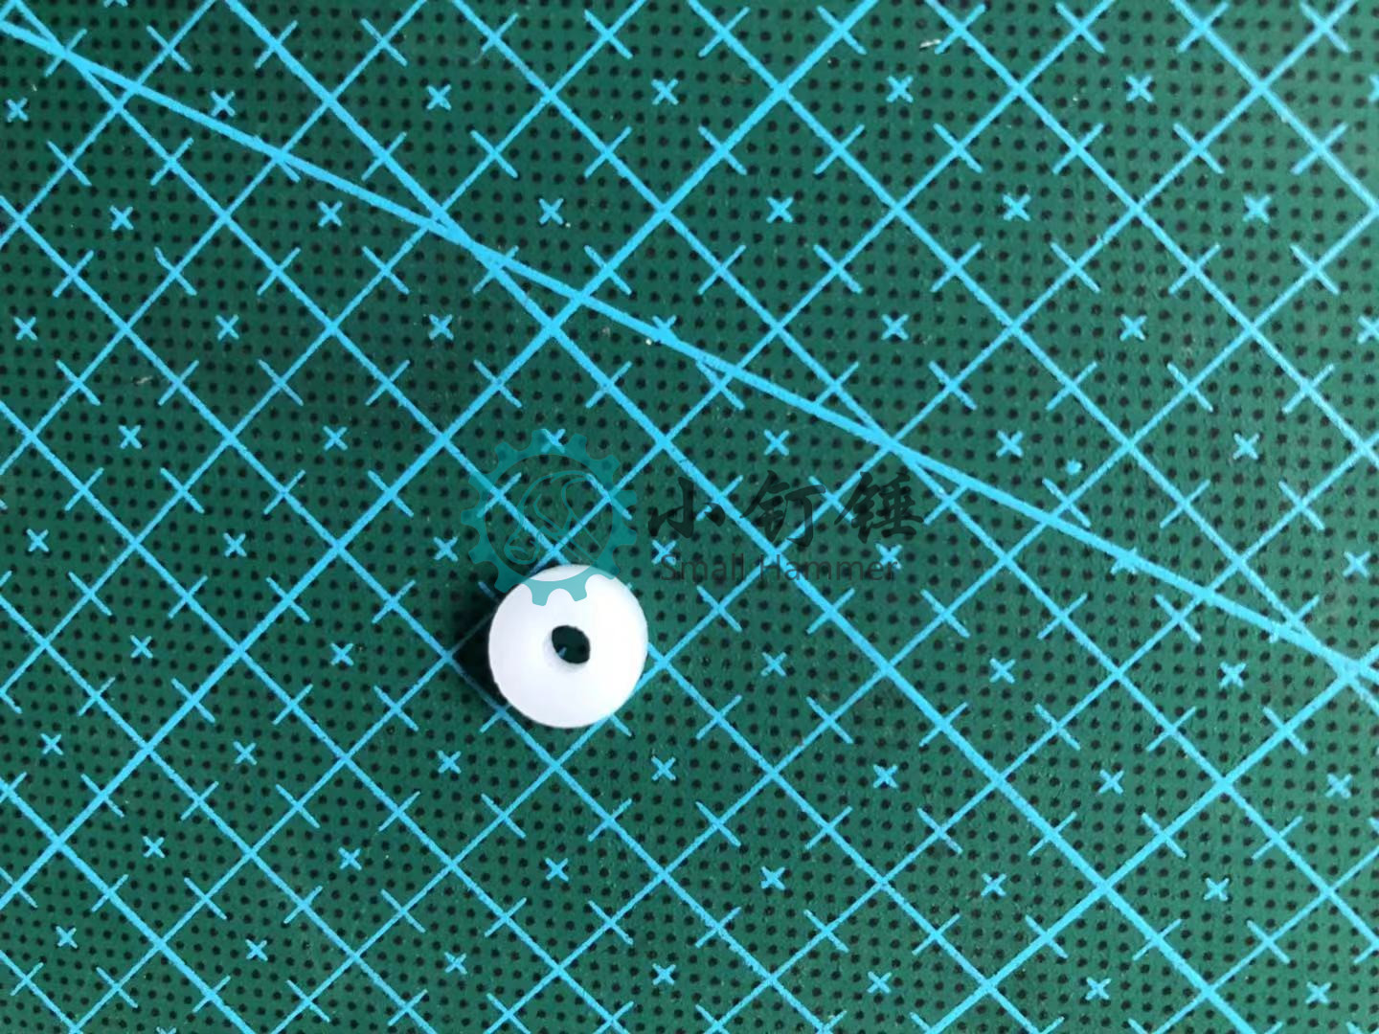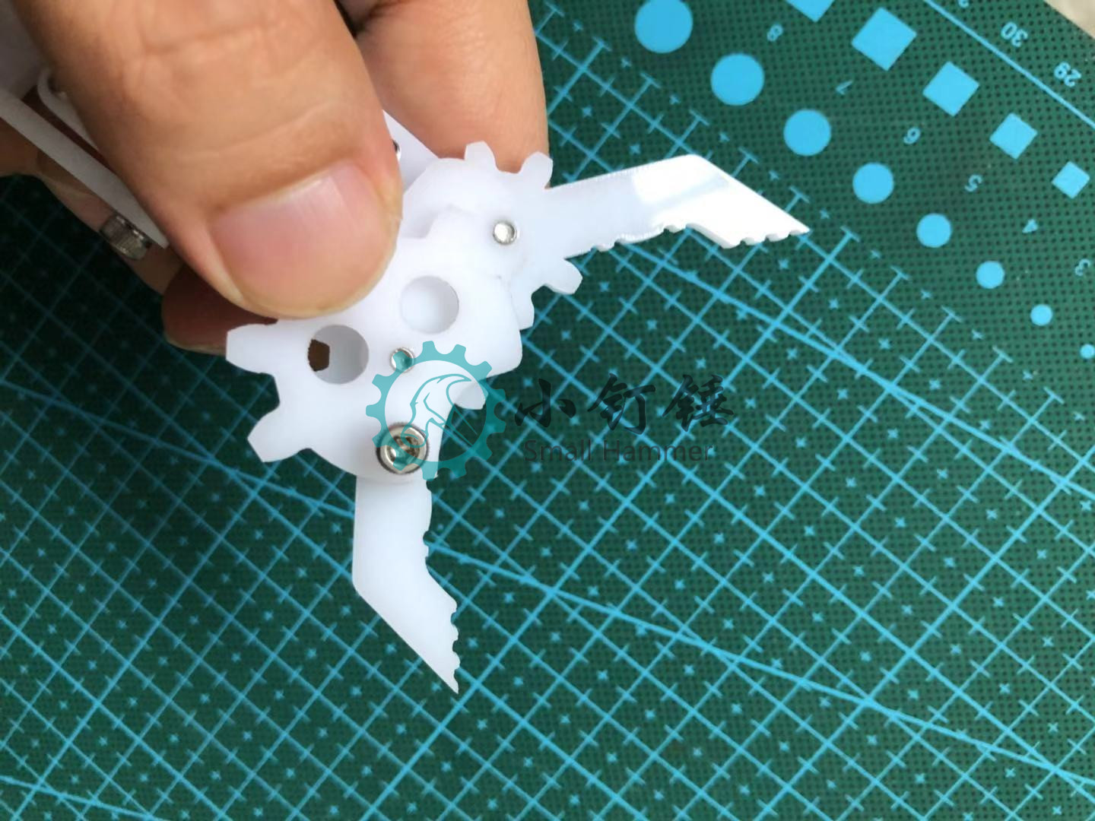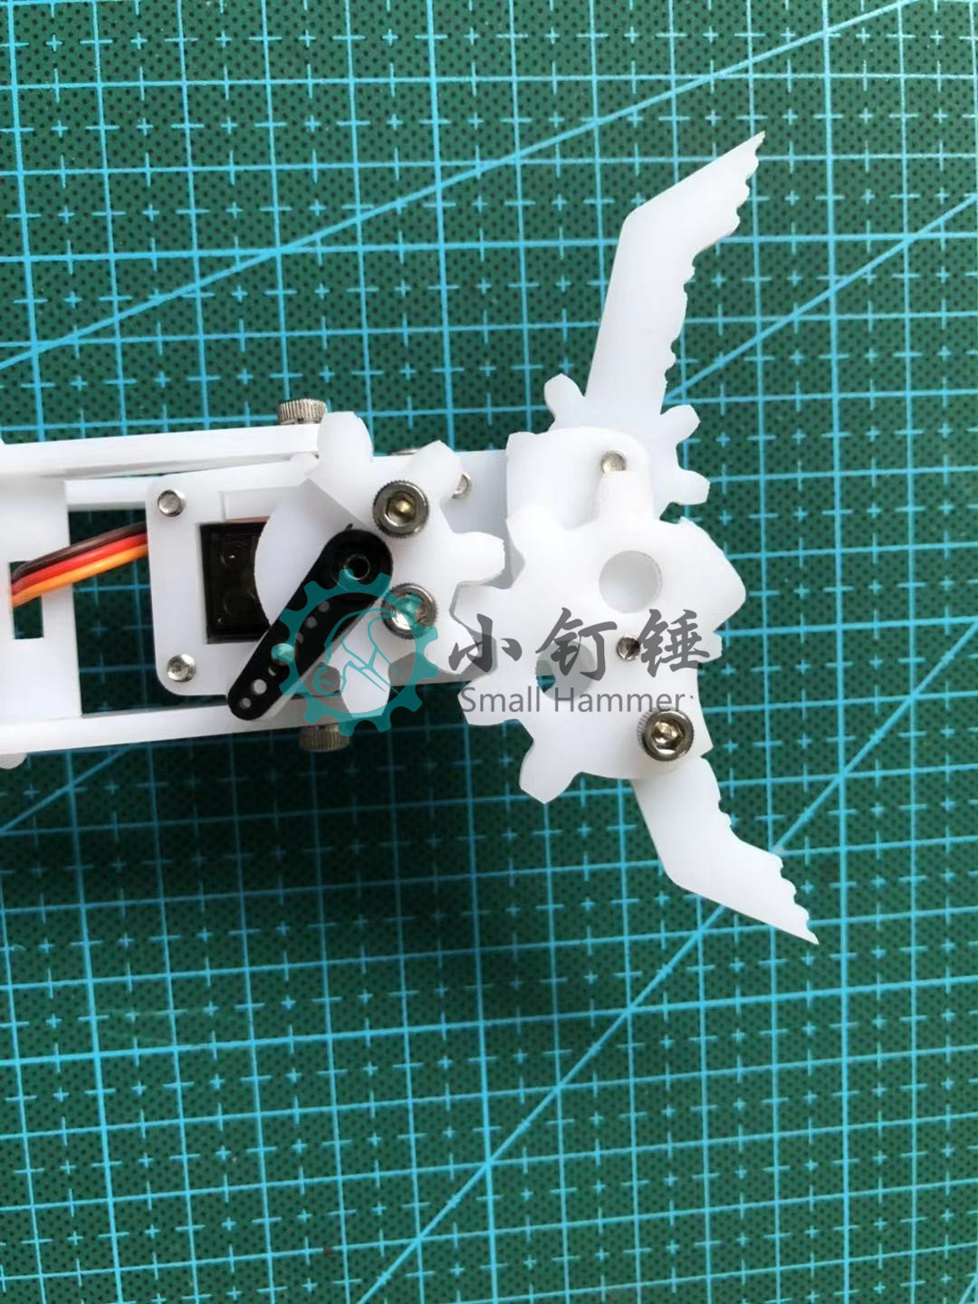

# 13, connect the claw

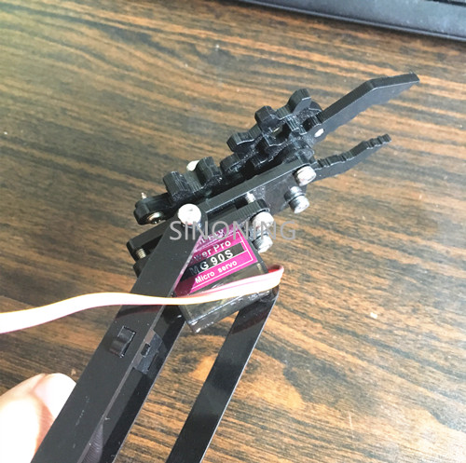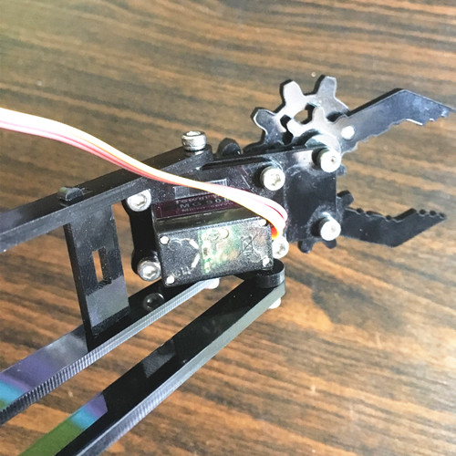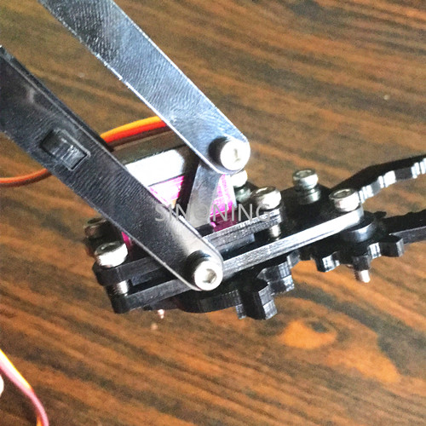

# update log

Newest Update：

2018.10.23

2018.09.28

2017.12.24

2017.05.25

2017.05.18

2016.09.12

2016.05.02

# arduino code

**Arduino code :**

[download](http://cdn.sinoning.com/code/snarm.zip) 2017.05.25

before ship out, we already upload upload code to uno board



# Note

Note:

Because the different joints corresponding to the degree of different, so you have a servo test, find the corresponding slot

# update log

Newest Update：

2018.10.23

2018.09.28

2017.12.24

2017.05.25

2017.05.18

2016.09.12

2016.05.02